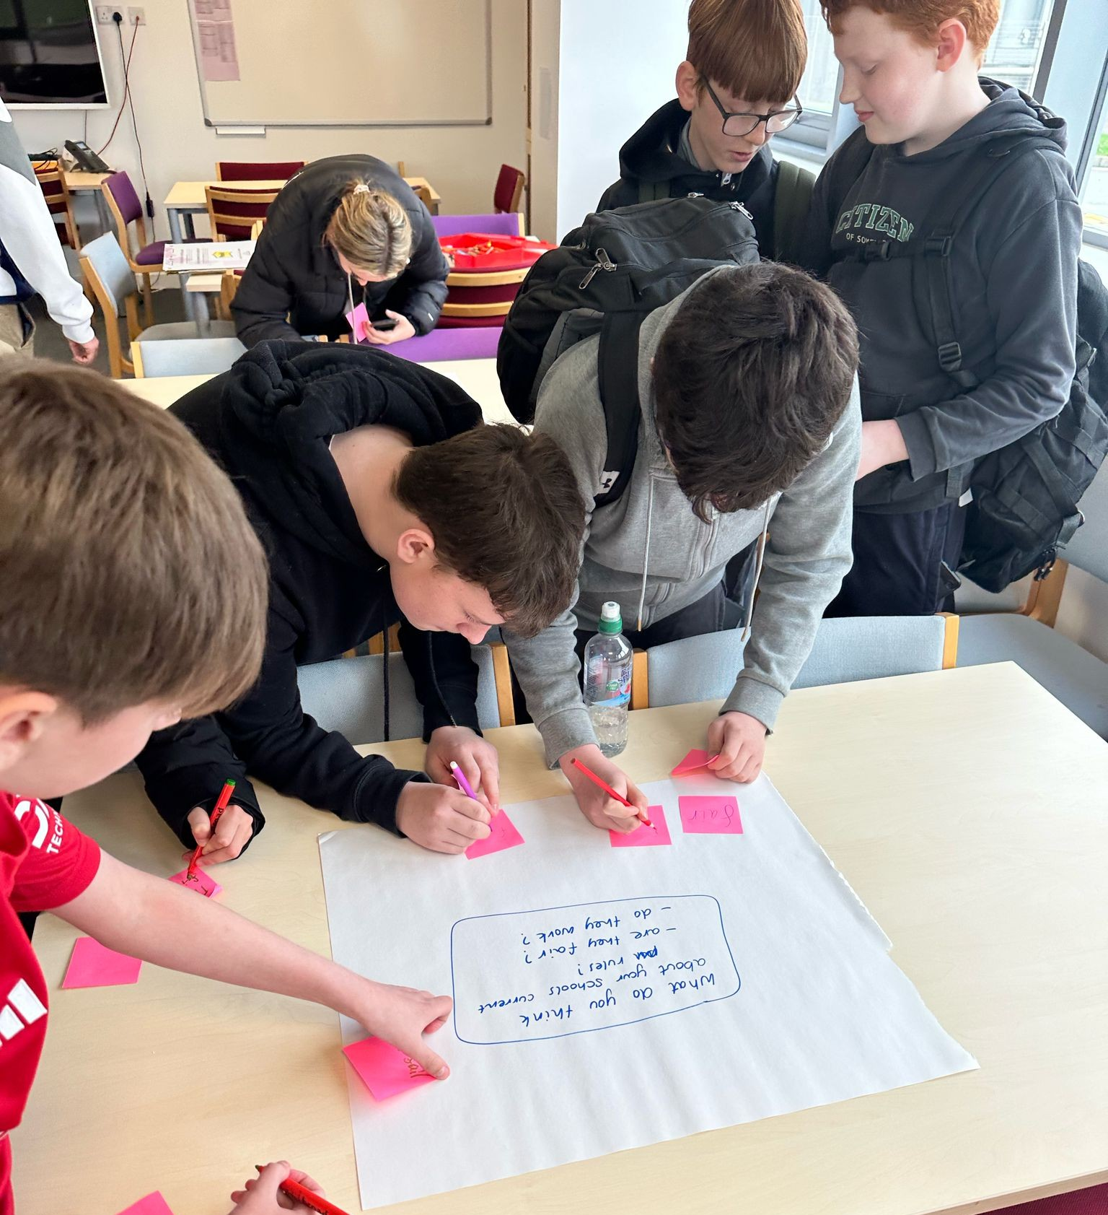
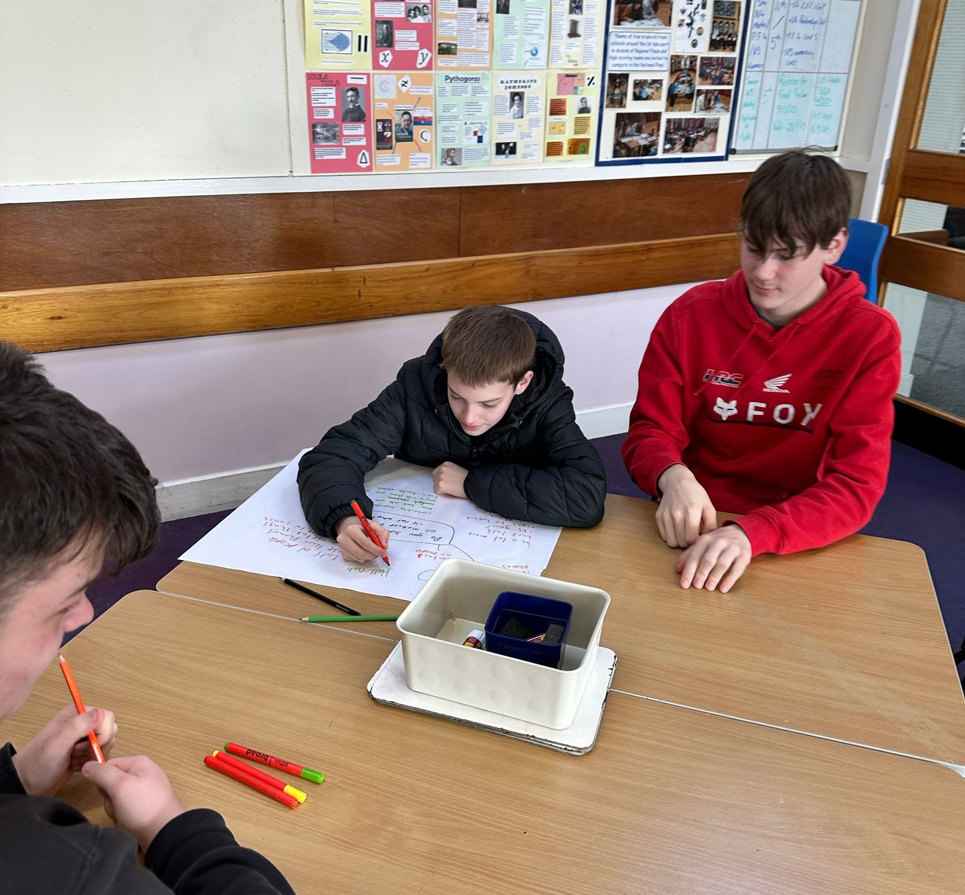
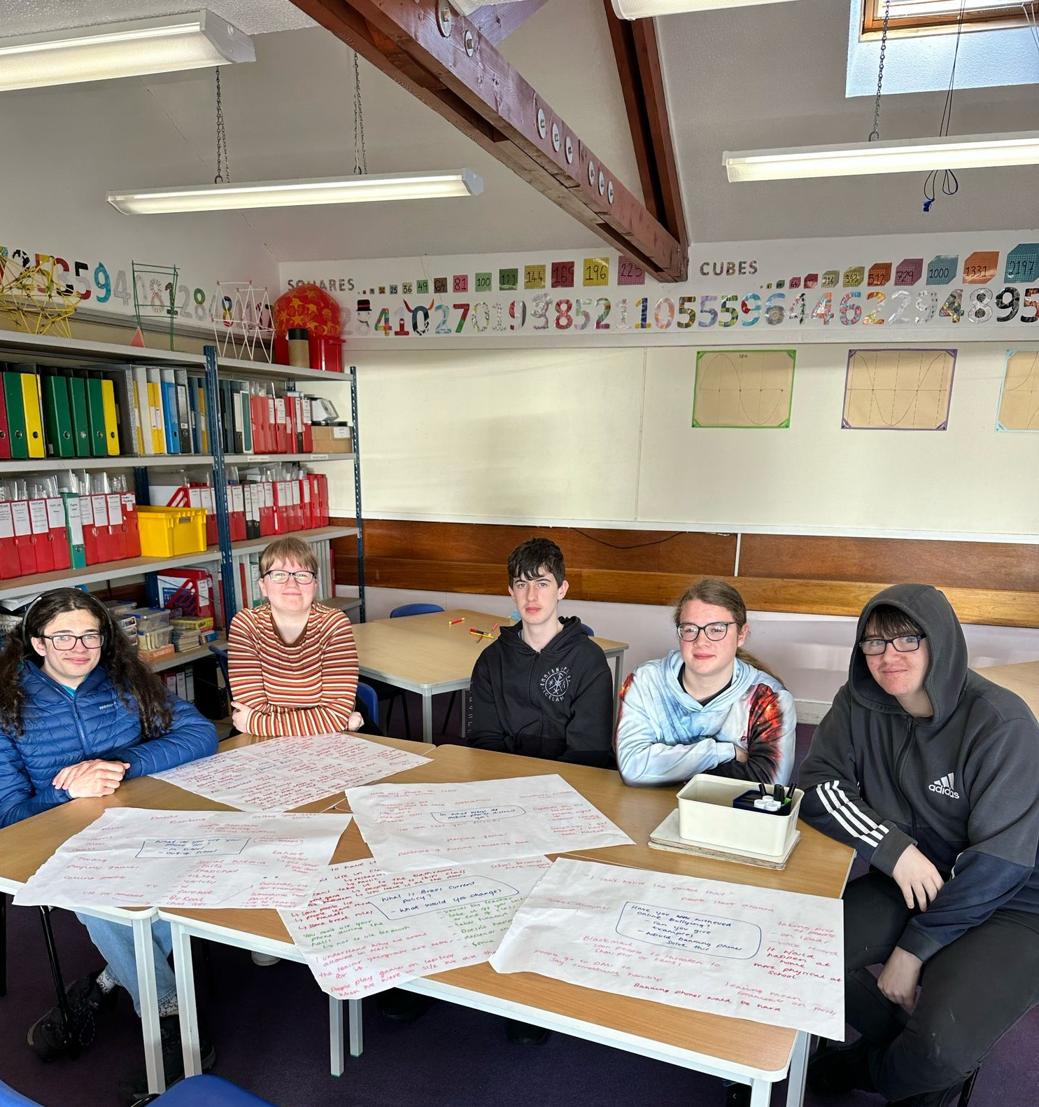
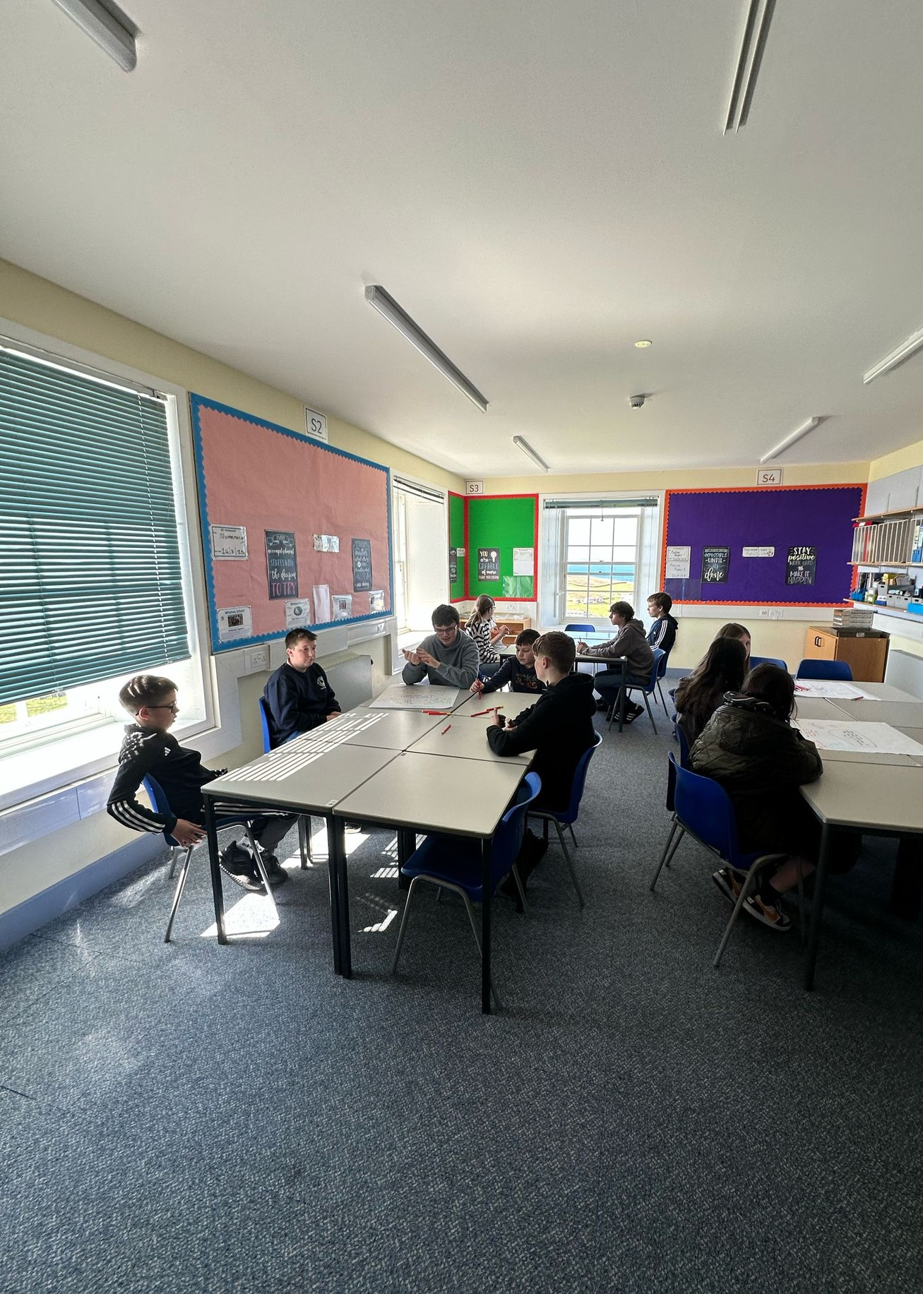

Mobile Phones in Schools
Focus Groups



MOBILE PHONES IN SCHOOLS FOCUS GROUPS APRIL 2025
1
AIMS & OBJECTIVES
The Youth & Employability Service held focus groups with S1–S6 pupils in every secondary school across Shetland to explore young people's views on mobile phone use in school.

The aim of this work was to understand how mobile phones impact learning, wellbeing, and school life from the perspective of students themselves.

Our objectives were to:

Gather honest feedback directly from pupils
Explore the benefits and challenges of mobile phone use in schools
Find out what kind of mobile phone guidance pupils would like to see in the future
Ensure that the voices of young people help shape updated guidance across Shetland schools

METHOD
2

A focus group is a small group discussion where people are invited to share their thoughts, experiences, and ideas about a particular topic. For this project, we spoke with pupils from S1 to S6 in every secondary school across Shetland to hear their views on mobile phones in school. Focus groups are a useful way to explore opinions in more depth than a survey, helping us to understand what matters most to young people. They allow for open conversation, where participants can reflect, agree, disagree, and build on each other’s ideas. This helps ensure that any future decisions are shaped by the real experiences and views of those involved.

ANDERSON HIGH SCHOOL
FINDINGS


Focus groups were held in the Anderson High School as a drop in over break time and lunch time over two days. This was due the focus groups being held so close to the exam period. due to low engagement in the drop in sessions (around 20 pupils) Youth Development Workers went around the social areas to hear feedback from students.
80% OF STUDENTS MENTIONED THAT THEY CONTACT THEIR PARENTS FIRST DURING SCHOOL

80%

SAMPLE 20 STUDENTS

15%
SAMPLE 20 STUDENTS

15% OF STUDENTS SAID THAT IPADS AND LAPTOPS WOULD REDUCE THE NEED FOR PHONES


Anderson High School pupils gave the most varied feedback. They discussed phone use in learning such as searching for information, using Blooket, checking TEAMs, and listening to music while revising, but also openly acknowledged extensive personal use for Snapchat, YouTube, TikTok, and messaging. Distractions were a dominant theme, especially in classrooms where teachers didn’t enforce clear rules. Some pupils noted they talked more during breaks when phones were put away, while others felt phones could be part of social interaction too. Safety and contact with parents were mentioned as essential reasons to carry phones. Most pupils opposed a total ban, instead calling for consistent enforcement of rules across subjects and staff.

Mobile Phones in Schools
Focus Groups
3
“Snapchat distracts you even when you don’t want to go on it” “We use it for Blooket or to find chords in music”
“We feel safe having our phones if something happens”

“Some teachers don’t care and some shout at you for just having it out” “Without phones, we talk more at break”
DO YOU SUPPORT A MOBILE
PHONE BAN? YES 0% NO 100%


Mobile Phones in Schools
Focus Groups


AITH JUNIOR HIGH SCHOOL
Focus groups were held at Aith Junior High School as a cross- section of the school. We discussed mobile phone usage with S1- S4 pupils from a variety of backgrounds

SAMPLE 18 STUDENTS

61%

50%
SAMPLE 18 STUDENTS
61% OF STUDENTS MENTIONED THAT THEY
CONTACT THEIR PARENTS FIRST DURING SCHOOL

50% OF STUDENTS SAID THAT IPADS AND LAPTOPS WOULD REDUCE THE NEED FOR PHONES

Pupils at Aith Junior High School described using their phones for a range of both educational and personal activities. They mentioned tools like Kahoot and Quizlet as useful when school technology wasn’t available, especially in classrooms where teachers encouraged digital participation. they all mentioned use such as YouTube and music, particularly during break and lunch times. Despite this, pupils acknowledged that phones could easily become a distraction, especially when used for entertainment. There was a strong consensus that phones provided a sense of security, especially when travelling to and from school in remote areas. While they did not support a blanket ban on phones, pupils expressed preference for fair and consistent rules across classrooms that allowed phones to be used responsibly and when appropriate.
“We use our phones to listen to music and to watch YouTube” “Some teachers use phones for Kahoot and Quizlet”

“It’s not fair to ban them we like listening to music” “Helps us feel safe, especially if walking home in the dark”

DO YOU SUPPORT A MOBILE
PHONE BAN?

YES 0% NO 100%


BRAE HIGH SCHOOL
Mobile Phones in Schools
Focus Groups
Focus groups were held at Aith Junior High School as a cross- section of the school. We discussed mobile phone usage with S1- S6 pupils from a variety of backgrounds. We held two large scale focus groups reaching around 35 pupils who added to the discussion

SAMPLE 35 STUDENTS

34%

6%
SAMPLE 35 STUDENTS
34% OF STUDENTS MENTIONED THAT THEY
CONTACT THEIR PARENTS FIRST DURING SCHOOL

6% OF STUDENTS SAID THAT IPADS AND LAPTOPS WOULD REDUCE THE NEED FOR PHONES

At Brae High School, pupils highlighted phone use primarily for music, messaging, and occasional schoolwork when laptops weren’t available. MS TEAMs and other apps were mentioned as used during the school day, but noted that every time a laptop was used then it would lead to technical issues. Social media was again a common source of distraction, and pupils admitted it was hard to resist checking phones when they buzzed. Frustration with inconsistent rules was a clear theme; students felt that unclear boundaries led to confusion and unfairness. They expressed support for phone access during non-teaching times and favored teacher controlled use over strict bans. Safety and parental contact were also named as important reasons to keep phones during the day. Many students from Brae High School noted that while some teachers had different rules to others, it was rare that they would get their phone removed during class as many respected the teachers rules.

“We would prefer to be able to use our phones between classes to check messages... this would stop me checking my phone in class”
“It’s hard not to check messages if your phone is buzzing”
“A full ban would just make people hide them more or take in a “fake phone” to hand to the teachers”

DO YOU SUPPORT A MOBILE
PHONE BAN?


YES 15% NO 85%


BALTASOUND JUNIOR HIGH SCHOOL
Mobile Phones in Schools
Focus Groups
Focus groups were held at Baltasound Junior High School as a cross-section of the school. We discussed mobile phone usage with S1-S4 pupils from a variety of backgrounds reaching around 20 pupils in the school.

SAMPLE 20 STUDENTS

2%

40%
SAMPLE 20 STUDENTS
2% OF STUDENTS MENTIONED THAT THEY CONTACT
THEIR PARENTS FIRST DURING SCHOOL

40% OF STUDENTS SAID THAT IPADS AND LAPTOPS WOULD REDUCE THE NEED FOR PHONES

Pupils at Baltasound described using their phones for simple, practical purposes such as taking photos of homework or using them for research when computers weren’t working. Most of their phone use revolved around contacting family, particularly to arrange pick-ups or pass on messages about meeting after school. Though some distraction was acknowledged, pupils generally followed teacher instructions on phone use and accepted classroom restrictions. They were strongly in favour of being allowed to carry phones, especially given the rural location of the school and its transport challenges. The tone from Baltasound was practical and cooperative, with little emphasis on social media compared to other schools. Students also mentioned that they have little engagement with other schools, and they tend to make friends with students across Shetland on social media and this allows them to keep in contact.
“We can use our phones if the teacher lets us” “We take pictures of homework sometimes”
“I message my mum if I forgot something and she can bring it to me”
“Having my phone helps me stay in contact with the friends I have from other schools”

DO YOU SUPPORT A MOBILE
PHONE BAN?

YES 15% NO 85%

Mobile Phones in Schools
Focus Groups


SANDWICK JUNIOR HIGH SCHOOL
Focus groups were held at Sandwick Junior High School as a cross-section of the school. We discussed mobile phone usage with S1-S4 pupils from a variety of backgrounds reaching around 20 pupils in the school.
50% OF STUDENTS MENTIONED THAT THEY CONTACT THEIR PARENTS FIRST DURING SCHOOL

50%
SAMPLE 20 STUDENTS

SAMPLE 20 STUDENTS

10%
10% OF STUDENTS SAID THAT IPADS AND LAPTOPS
WOULD REDUCE THE NEED FOR PHONES

Sandwick pupils reported using their phones for a mix of messaging, music, and educational learning, such as accessing MS TEAMs or looking up help for schoolwork. Social apps like TikTok were mentioned as major distractions outside of school but not during the school day. Pupils also emphasised the importance of phones for feeling safe and being able to reach home, particularly when they need to discuss private issue with thier parents. Students mentioned that parents are supposed to contact the school office rather than text students, although this made them feel uncomfortable and report that it doesn't happen. They expressed there is a clear control of mobile phones and there is no need for a whole-school bans, and wanted teachers to also not use their phone during class, as they weren't allowed to. They viewed phones as useful and showed an awareness of balancing personal use with learning.

“I use it to message family if I need picked up or if I am going to meet my friends after school”
“TikTok is really distracting, but only after school”
“We use it for school stuff sometimes, like if we can’t log into a laptop or they are all booked up”
“Having it makes you feel safe like if something bad happens”

DO YOU SUPPORT A MOBILE
PHONE BAN? YES 5% NO 95%

Mobile Phones in Schools
Focus Groups


MID YELL JUNIOR HIGH SCHOOL
Focus groups were held at Mid-Yell Junior High School as a cross- section of the school. We discussed mobile phone usage with S1- S4 pupils from a variety of backgrounds reaching around 8 pupils in the school.

SAMPLE 8 STUDENTS

0%
SAMPLE 8 STUDENTS
37% OF STUDENTS MENTIONED THAT THEY
CONTACT THEIR PARENTS FIRST DURING SCHOOL

37%

0% OF STUDENTS SAID THAT IPADS AND LAPTOPS WOULD REDUCE THE NEED FOR PHONES

Pupils at Mid Yell Junior High School focused on communication as the main reason for having mobile phones. They described regularly using them to message parents and coordinate pick-ups or reminders. Students at Mid-Yell Junior High School stated that they are all given an IPad to help with learning, however they are hardly used and they were very slow and didn’t load. They also said that older pupils were given laptops to study with during exam time and the younger students found this exciting. Most pupils accepted rules about keeping phones away during lessons and appreciated when teachers made expectations clear. Students in Mid-Yell are told their phones has to be in bags, but many stated that this rule is broken and that they keep them in pocket Overall, pupils supported maintaining access to phones, but within clearly defined boundaries during class time.
“I use it to message family if I need picked up or if I am going to meet my friends after school”
“TikTok is really distracting, but only after school”
“We use it for school stuff sometimes, like if we can’t log into a laptop or they are all booked up”
“Having it makes you feel safe like if something bad happens”

DO YOU SUPPORT A MOBILE
PHONE BAN?

YES 0% NO 100%

Mobile Phones in Schools
Focus Groups


WHALSAY JUNIOR HIGH SCHOOL
Focus groups were held at Whalsay Junior High School as a cross-section of the school. We discussed mobile phone usage with S1-S4 pupils from a variety of backgrounds reaching around 15 pupils in the school.

5%
5% OF STUDENTS MENTIONED THAT THEY CONTACT THEIR PARENTS FIRST DURING SCHOOL

SAMPLE 15 STUDENTS

19%
SAMPLE 15 STUDENTS

19% OF STUDENTS SAID THAT IPADS AND LAPTOPS WOULD REDUCE THE NEED FOR PHONES

At Whalsay School, pupils spoke positively about having mobile phones, especially for staying connected with friends. They felt it was important to have a way to contact home if plans changed or if they are catching a ferry straight after school they need their phone for contact later on. Some pupils shared that they enjoyed watching the boats come in and out of the harbour and liked being able to use apps such as Marine Traffic to see the boats. Many stated that ferries are essential to check ferry times. They also said that phones helped them keep in touch with friends from other schools. While apps like TikTok and messaging were mentioned as distractions, most pupils felt they could manage their phone use and understood when it was appropriate to use them. They said that some teachers already allowed phones to be used in a controlled way for example, during breaks or for specific tasks and they appreciated this balanced approach. There was no strong feeling that major changes to the current rules were needed. Instead, pupils supported having clear, fair guidance that lets them use phones when it makes sense.
“Nobody gets in trouble for using their phones, everyone sticks to the rules” “I don’t have a phone, and I don’t need one... not yet”
“I need my phone to check ferry time table, and when I need to speak to my Mum & Dad”
“Having it makes you feel safe like if something bad happens”


DO YOU SUPPORT A MOBILE
PHONE BAN? YES 30% NO 70%

Mobile Phones in Schools
Focus Groups
4

RAW DATA PHOTOS

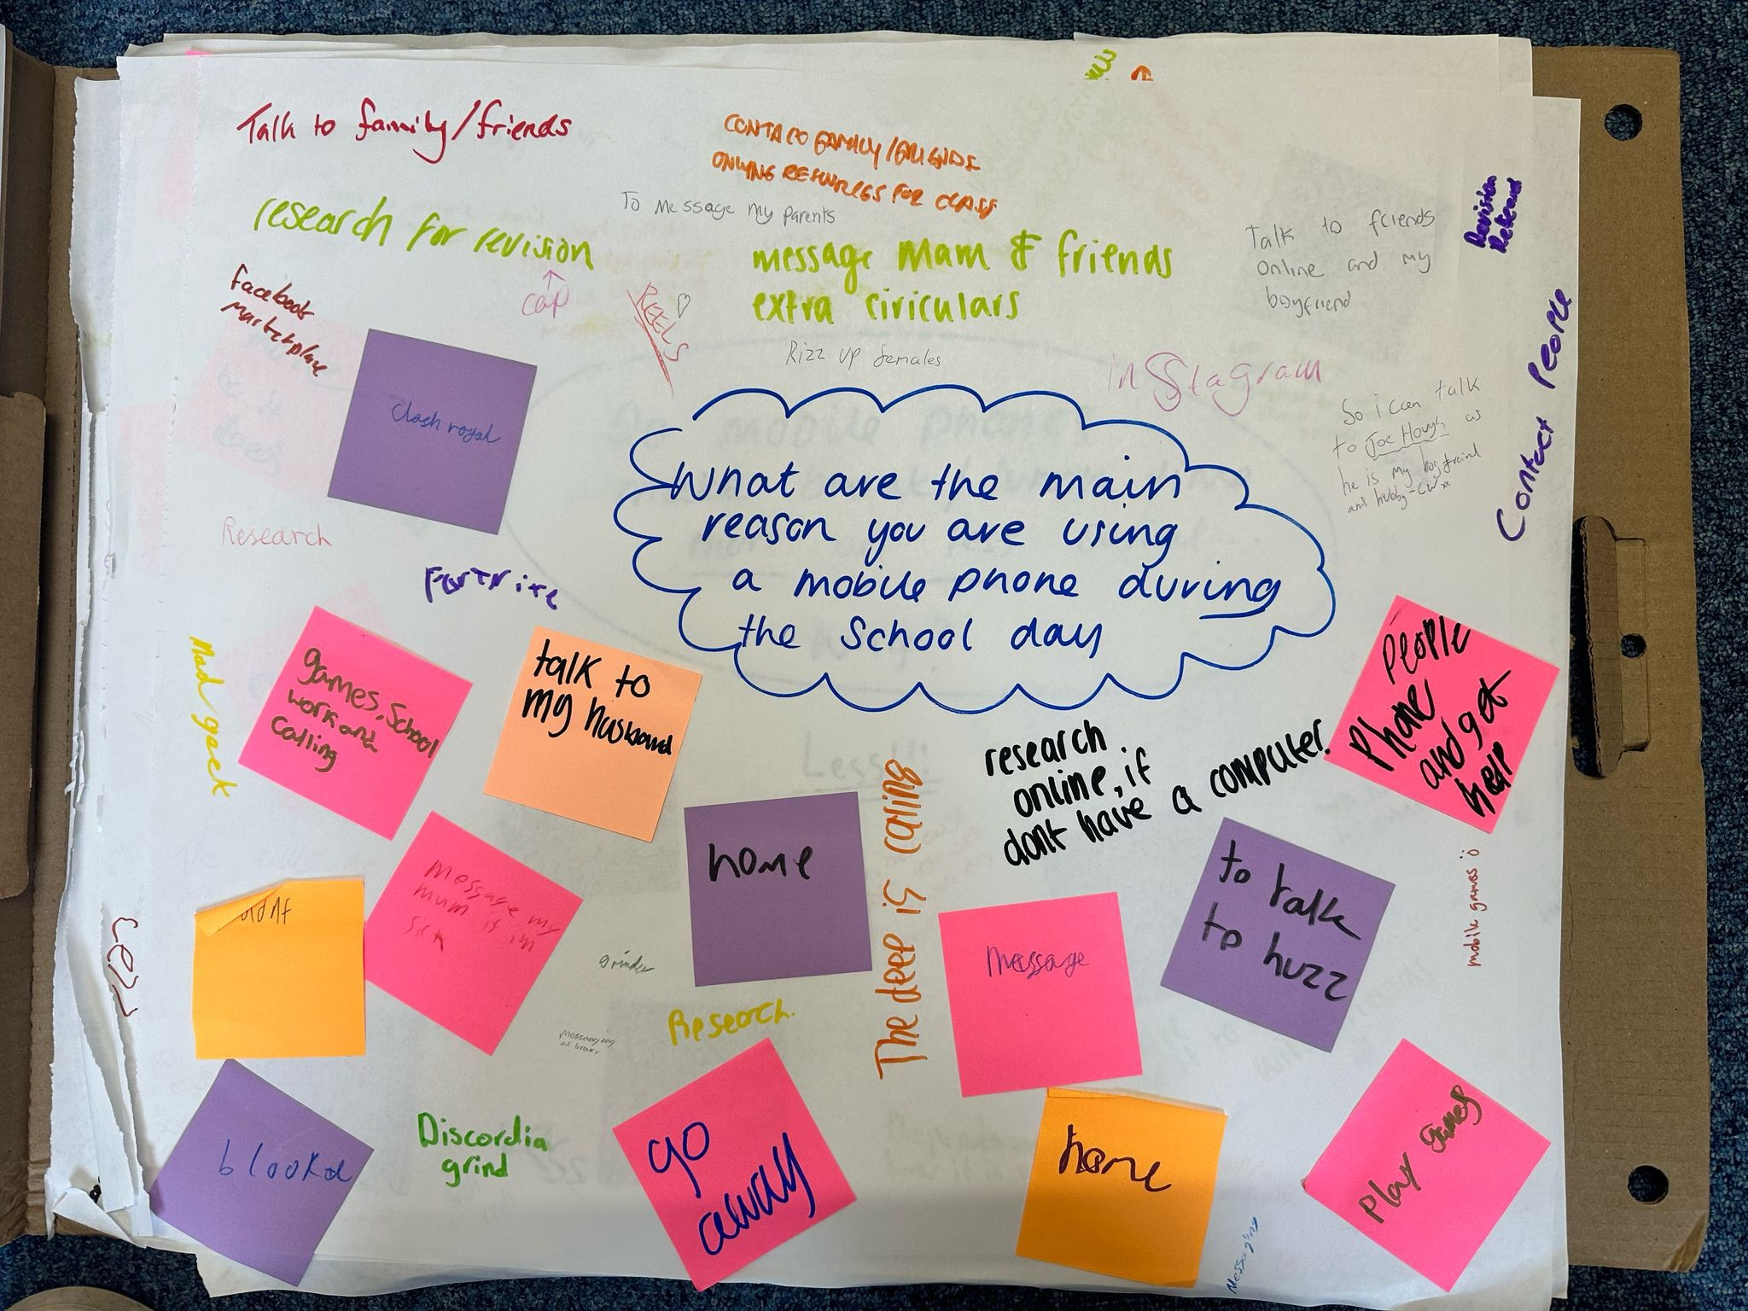
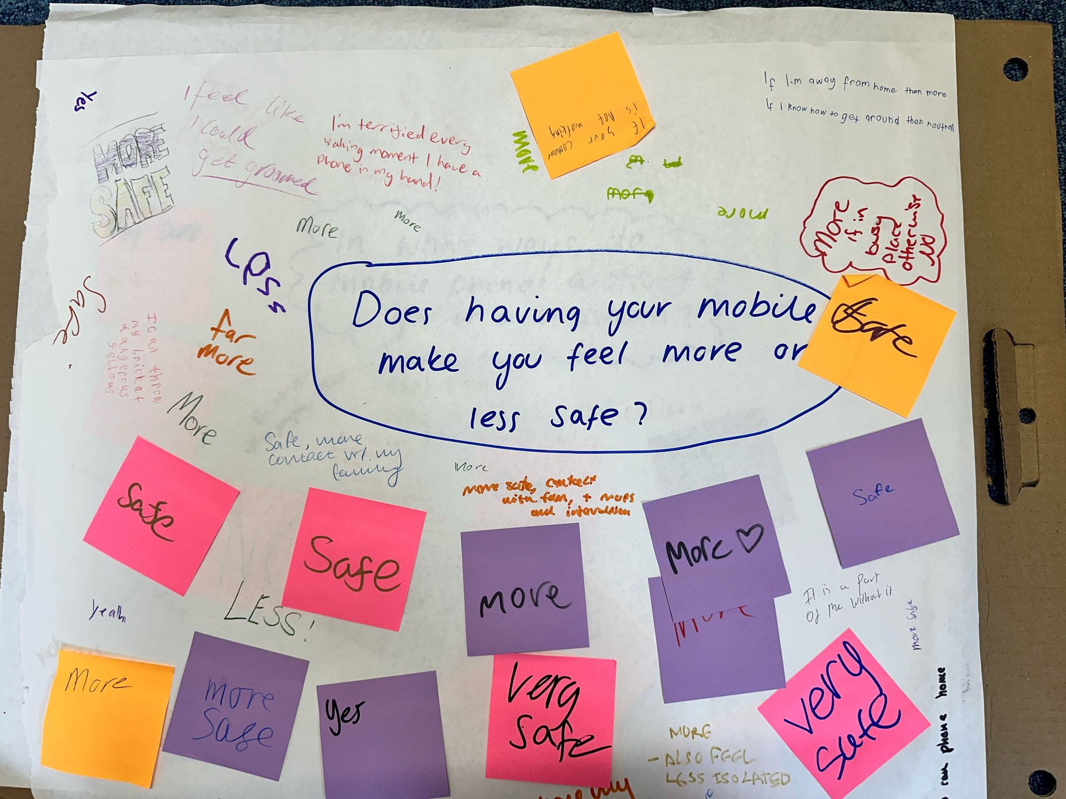

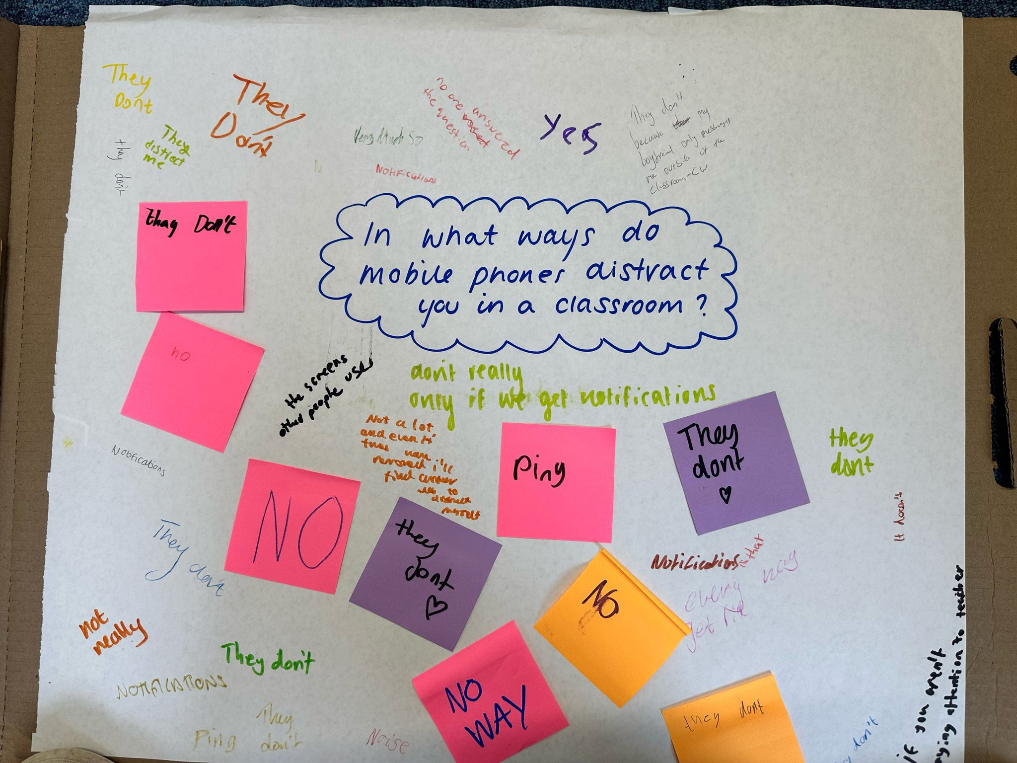
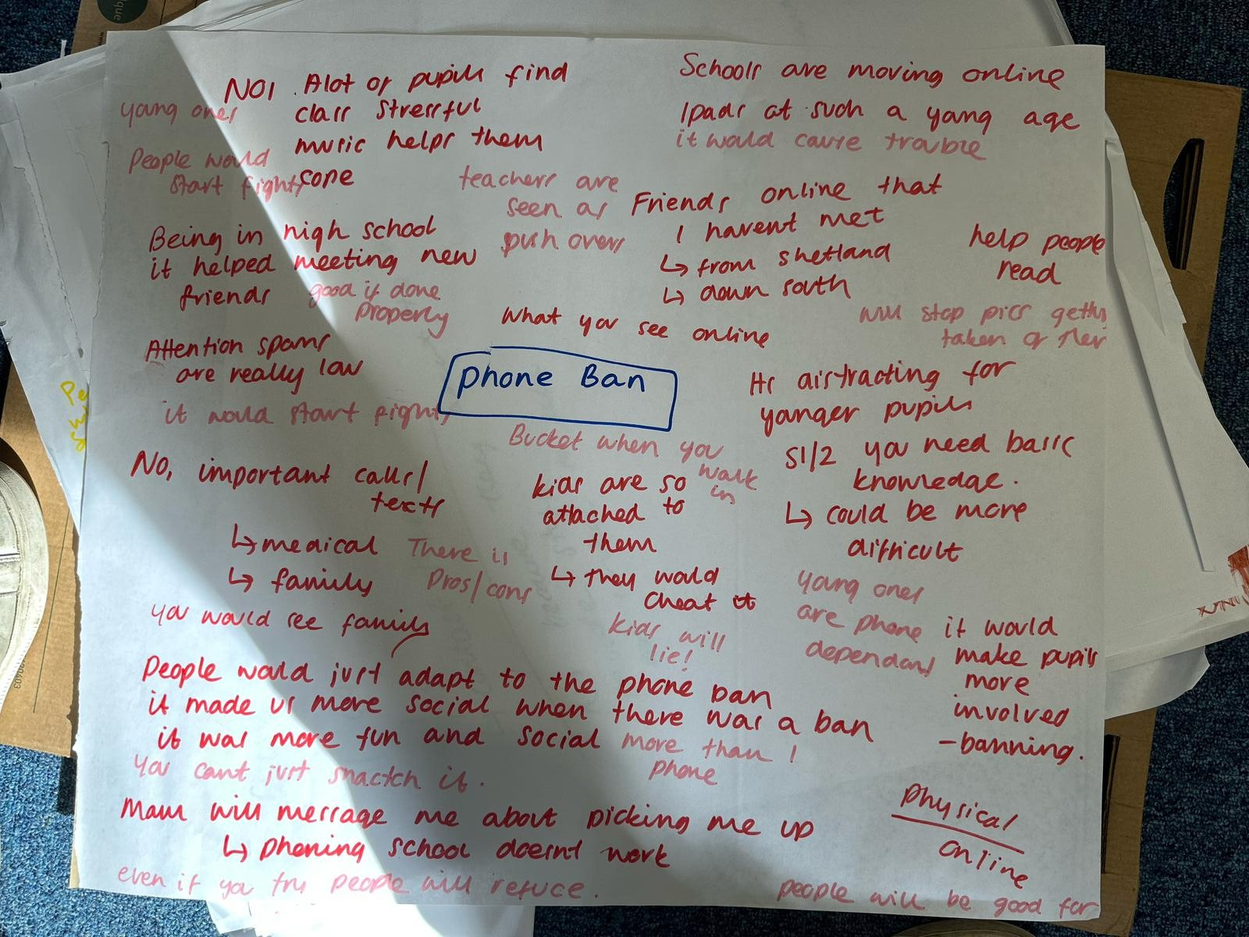
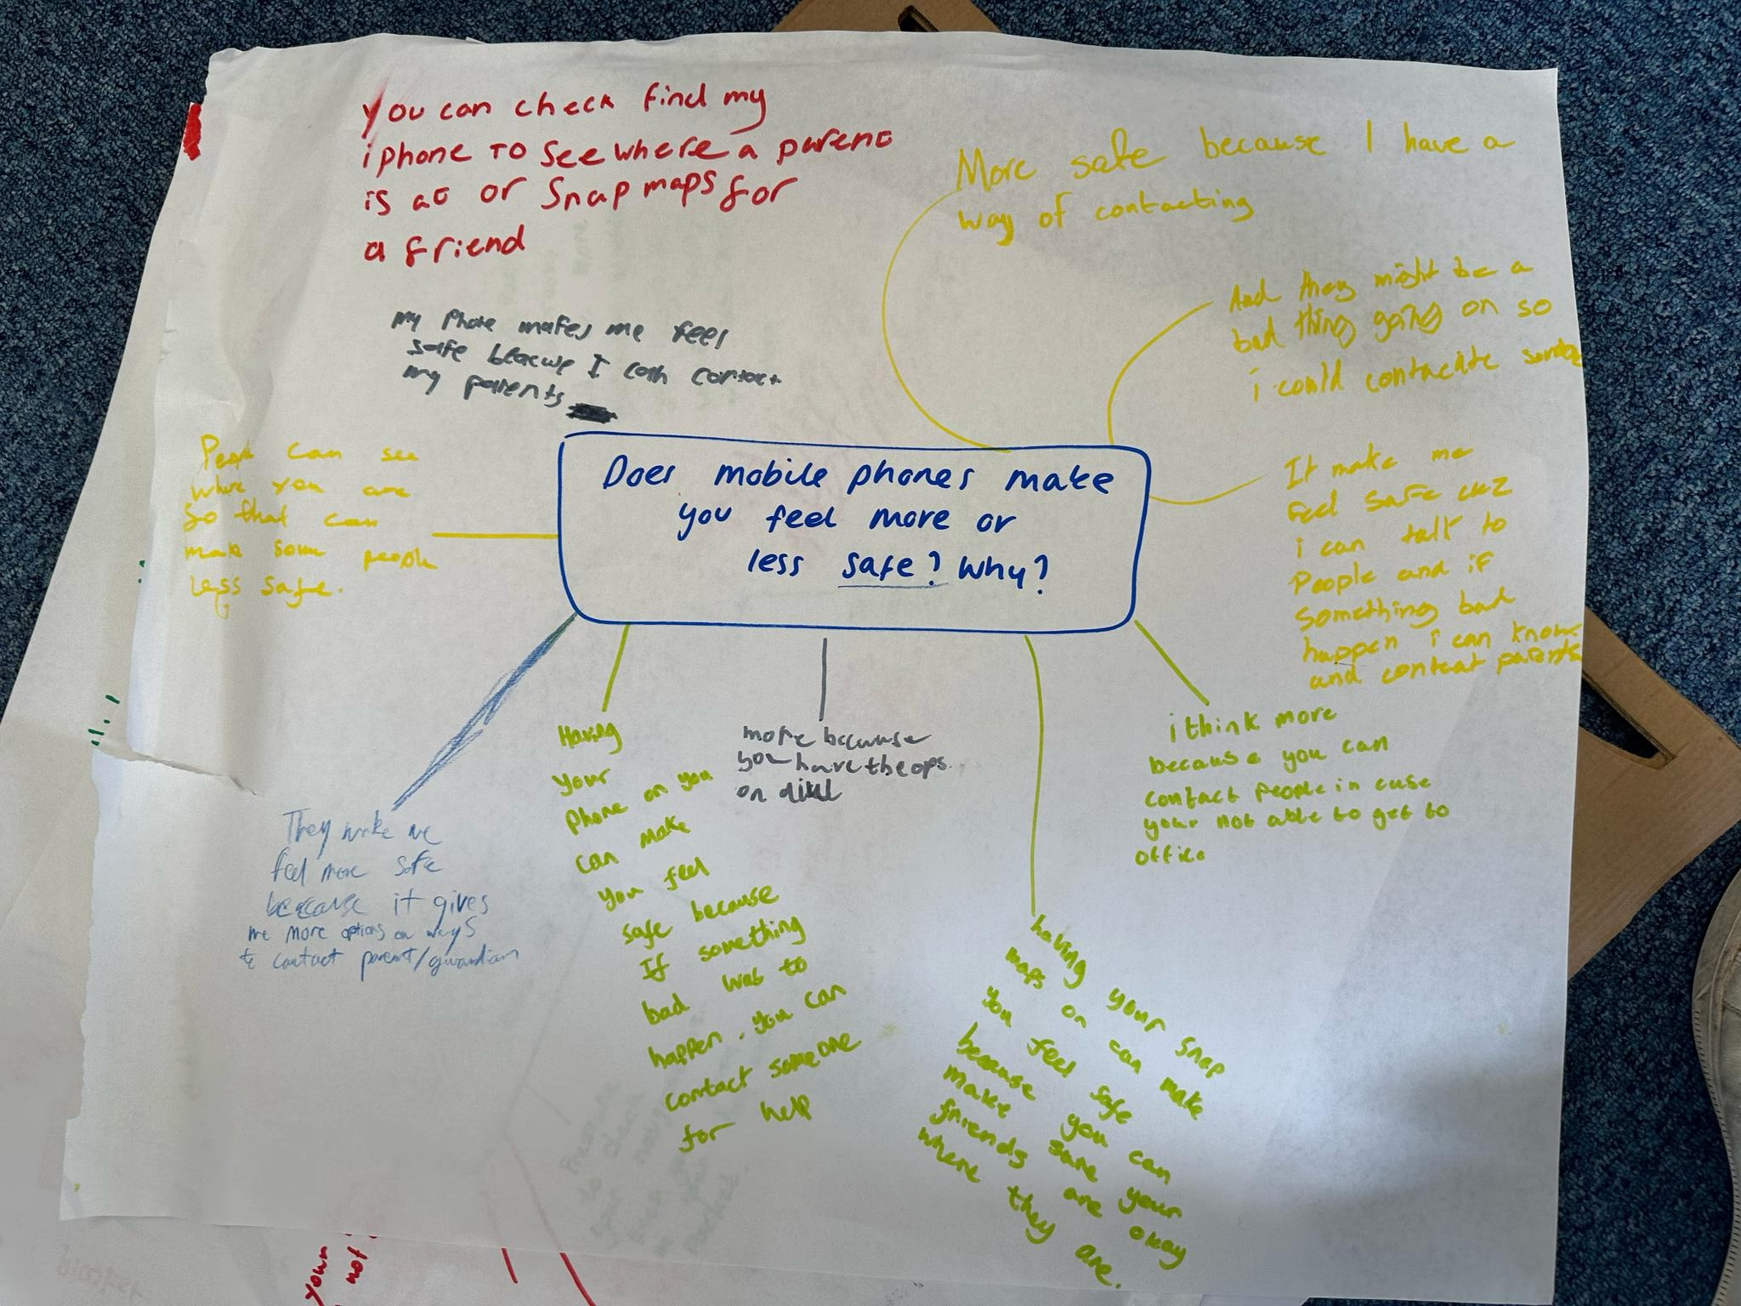
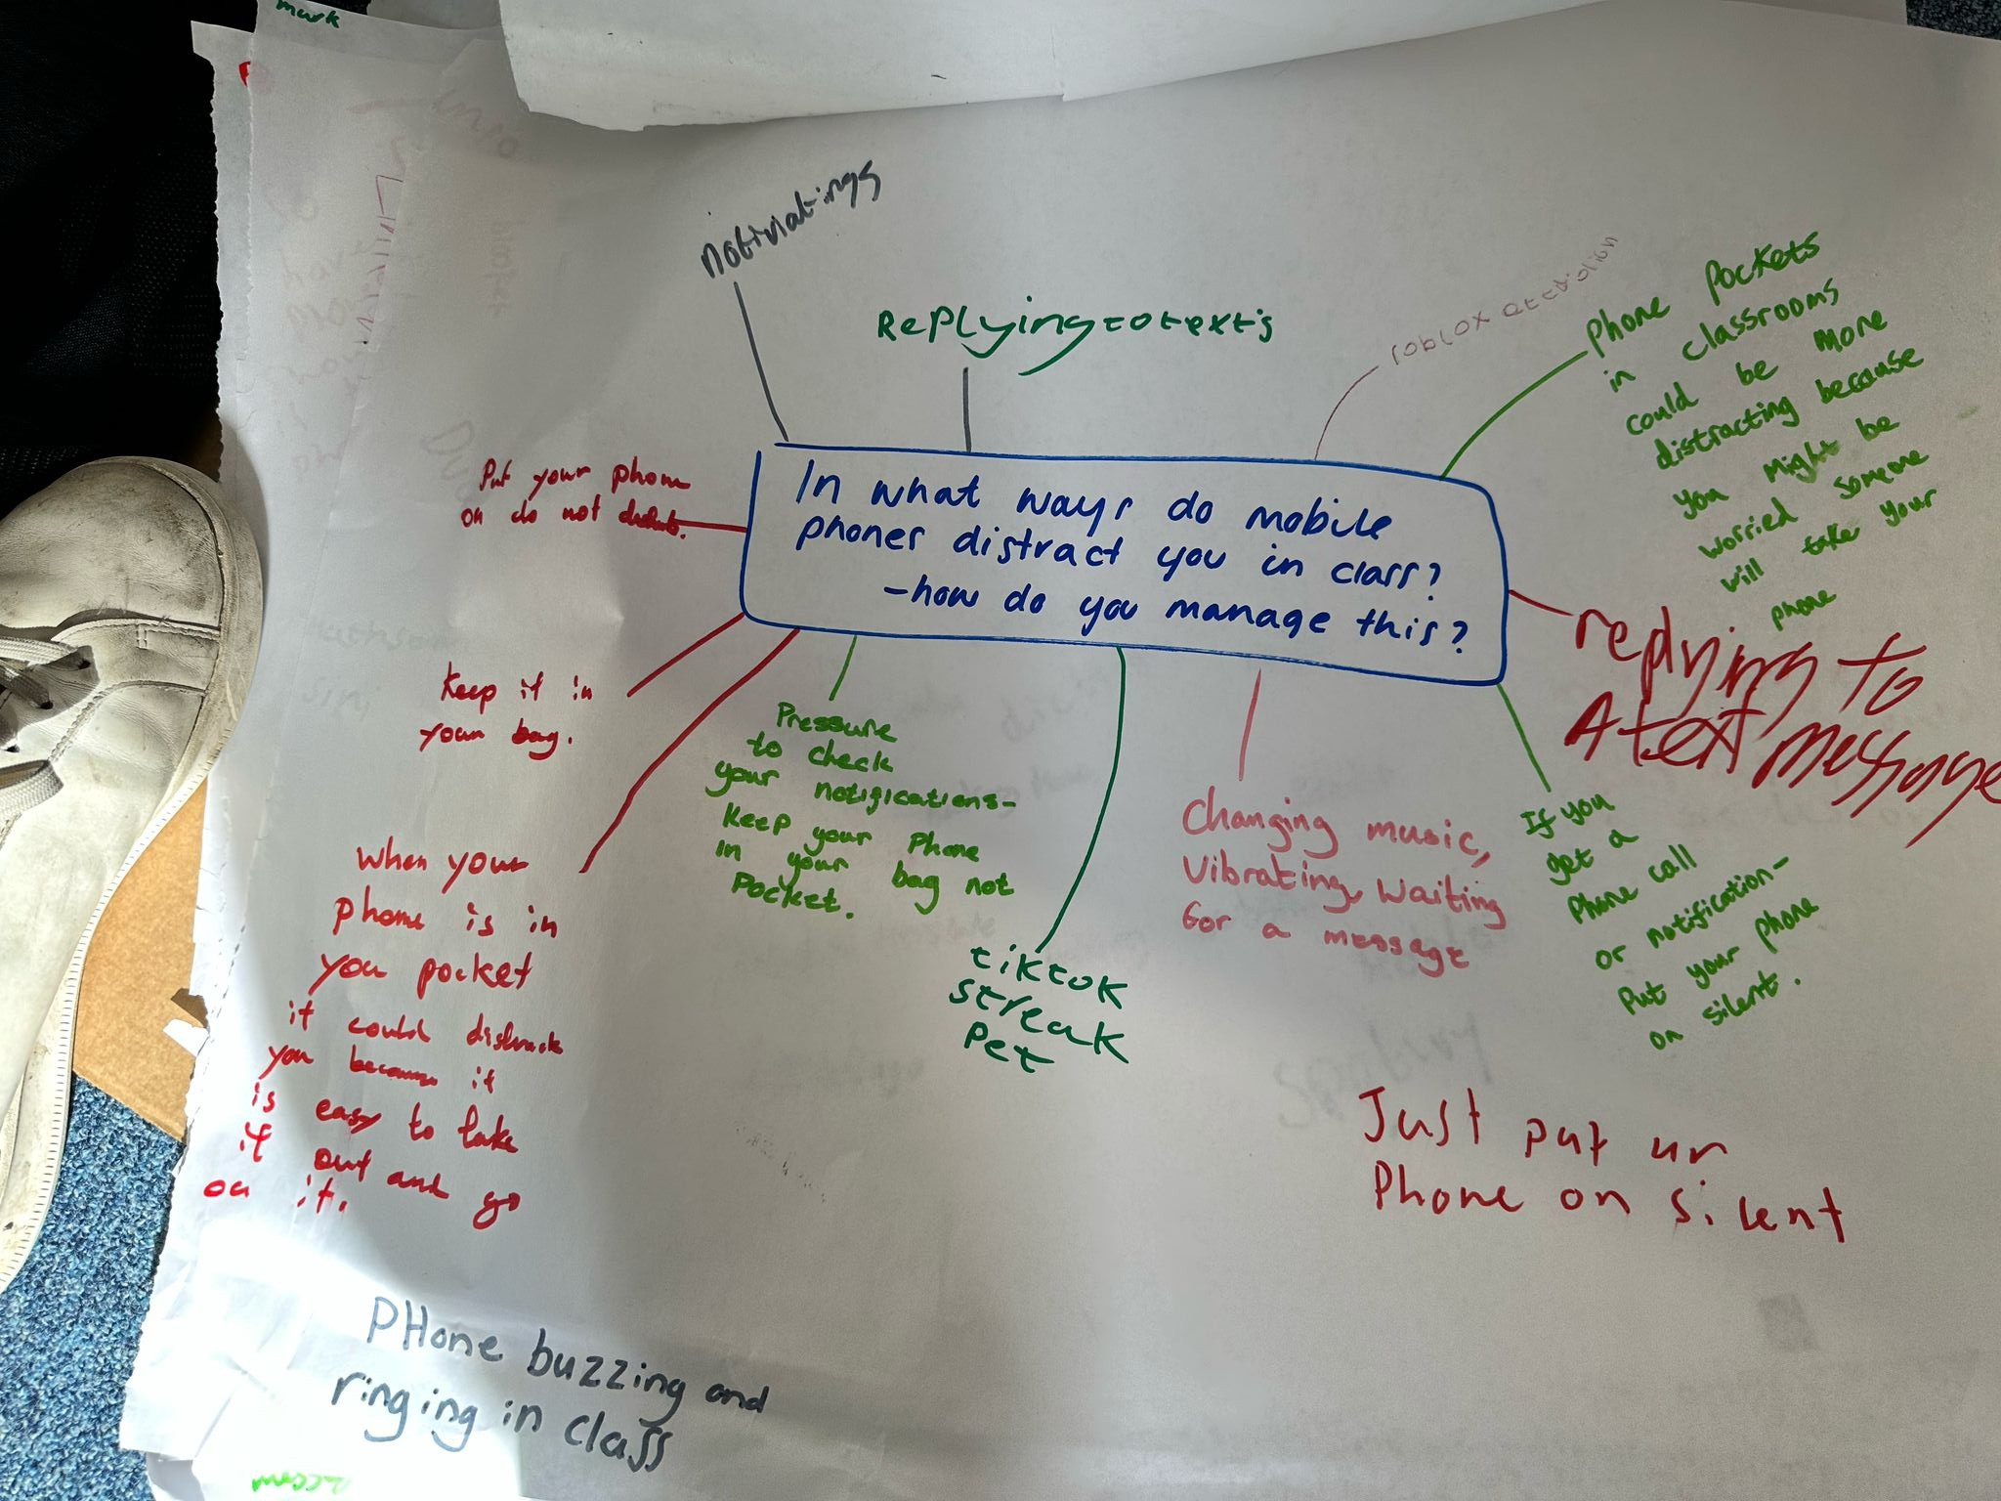

Mobile Phones in Schools
Focus Groups

CONCLUSION OF THEMES
5

The focus groups held across Shetland’s secondary schools gave us detailed insight into how pupils view mobile phones in school. Their views were clear, consistent in some areas, and varied in others. They showed a good understanding of the pros and cons. This conclusion summaries what pupils said about each of the main themes.

Safety:
Across all schools, pupils said having a phone made them feel safer. This was especially important in rural areas, where pupils often travel long distances or rely on ferries and buses. They said phones helped them stay in touch with home, manage changes to plans, or deal with emergencies. This was one of the strongest reasons pupils gave for wanting to keep their phones at school.

Enhancing Learning:
Many pupils said phones can support learning when used in the right way. They mentioned using apps like TEAMs, Kahoot, Blooket, and Google for tasks when school devices weren’t available. Some used phones to look up information or help with revision. Pupils said phones are especially useful when laptops or iPads are broken or unavailable, and that they often filled gaps in resources.

Distractions:
Distraction was mentioned in every school. Pupils said apps like Snapchat, TikTok, and Instagram can take their attention away from learning sometimes even just from notifications. Some admitted it was hard not to check their phones during lessons. However, many also shared ways they manage distractions, like turning off notifications or keeping their phone in a bag or pocket during class.

Usage Patterns:
Pupils commonly used phones to message parents, listen to music, check travel times, or use social media outside of class. Some used them for schoolwork, especially when other tech wasn’t working. Some mentioned they like to have their phones in class on the table and this lessened anxieties from feeling like they don't know what is going on on their phone.

Mobile Phones in Schools
Focus Groups

School Policies:
One of the most repeated concerns was the inconsistency of rules between teachers and subjects. Pupils said they sometimes didn’t know what was allowed and felt it would be fairer if schools had clearer, more consistent rules. Most were not in favor of a full ban, but instead wanted clear guidance on when and how phones could be used responsibly.

Social Impact:
Pupils had mixed views on how phones affect social time. Some said phones made breaktimes quieter or less social, while others said they helped them connect with friends especially those from other schools or in different year groups. A few pupils said they preferred breaks without phones, as it encouraged more face-to-face chat.

Bullying:
Bullying wasn’t a major focus in most groups, but some pupils mentioned group chats or social media being used in unkind ways. A few described situations where photos had been shared without permission or where pupils were left out of online groups. Most said that while it wasn’t a big issue in their school, it was still something schools should keep an eye on.
Key Message:
Most pupils said they didn’t want phones banned altogether, but they also didn’t think phones should be allowed without limits. What they asked for was clear, fair rules that applied to everyone. Many supported having phones during breaktimes and for learning tasks as long as it was controlled by teachers. They also wanted to be involved in creating guidance that works for both pupils and staff.


CONTACT:
Sonny Thomason
Youth Participation & Empowerment Project Officer youthservices@shetland.gov.uk

