Shetland Islands Council
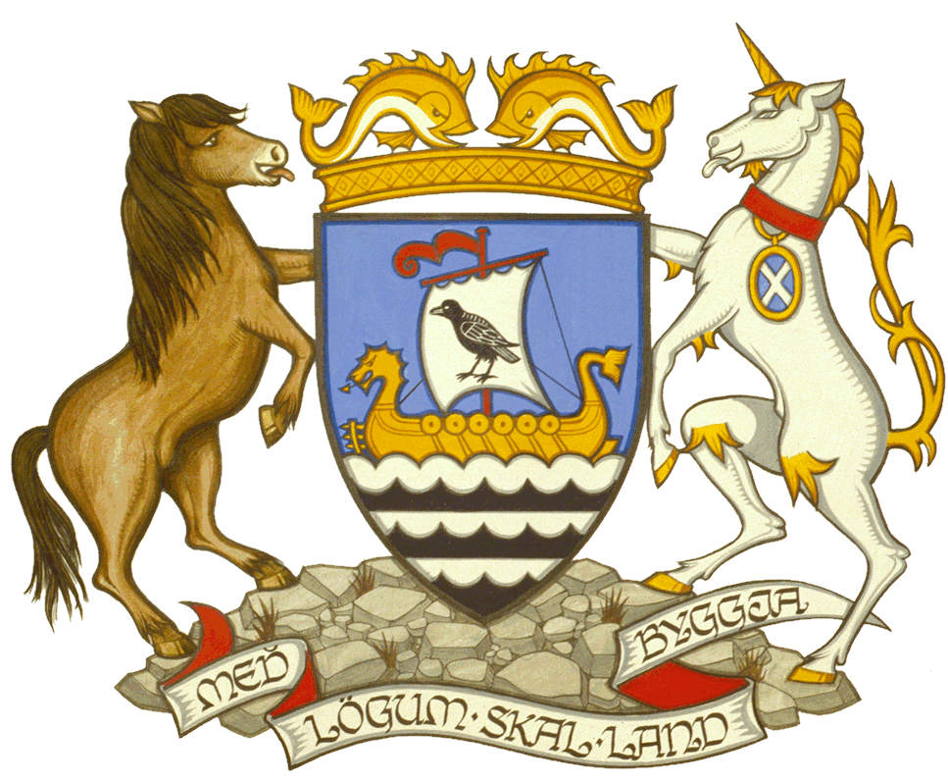
Scalloway Harbour Emergency Plan
Draft

September 2025

Note - In an emergency, go straight to Part C

Table of Contents
Table of Contents 2
Distribution List 4
Glossary of Terms 5
Amendment Log 6
Part A 7
How to use the plan 7
Introduction 8
Purpose 8
Key Objectives 9
Implementation 9
Organisational Structure 10
Roles and responsibilities 11
Category 1 Responders 11
The Emergency Services 11
Shetland Islands Council 11
Category 2 Responders 12
Scalloway Harbour Authority – Incident Management Team (Tactical Response) 12
Scalloway Harbour Authority - SIC Response Teams (Operational Response) 14
External Government Agencies 15
Incident Organigram 16
Part B 17
Activating the Emergency Plan 17
Notification that the plan has been activated 17
SHO / VTS – Decision Support System - When to call the DHM 19
DHM – Decision support system – When to activate the Emergency Plan 20
Communication 21
Contact Sheet 21
Notifications 23
Lines of Communication 24
Methods of Communication 27
Situation Reporting 27
Mobilisation 28
Mobilisation of SIC Incident Management Team (Tactical Response) 28
Co-Locating 28
Mobilisation of SIC Response Teams (Operational Response) 28
Rendezvous Point / Muster Point 29
Access to the RVP / MP 29
Landing Points 30
Access to Landing Points 31
Deployment 33
Deployment of SIC Response Teams 33
On Scene Commander Afloat / Ashore 33
Deployment of all other Harbour Vessels 33
Deployment of SIC Shore Teams 33
Standing Down 34
Debriefing & Review 34
Training and Exercise 36
Part C 38
Action Cards 38
Contact Sheet 39
Annex I - Identified Resources & Capabilities 130
Annex II - Incident Log 134
Annex III - Situation Report / METHANE Template 135

Distribution List

Number | Copy Holder | Location
 | Incident Room | Incident Room
 | Harbour Master | Harbour Master’s Office
 | Deputy Harbour Master | Deputy Harbour Masters’ Office
 | VTS | VTS
 | Port Safety Officers | Port Safety Officers’ Office
 | Small Ports Supervisor | Scalloway Harbour Office
 | Scalloway Harbour Office | Scalloway Harbour Office
 | Pilots | Scalloway Harbour Office
 | SIC Emergency Planning and Resilience Officer | SIC Emergency Planning and Resilience Office
 | Executive Manager – Marine Infrastructure and Airports | Executive Manager’s Office
 | Team Leader – Port Engineering Superintendent | Team Leader – Port Engineering Superintendents Office
 | Police Scotland | Lerwick Police Station
 | Scottish Fire and Rescue | Lerwick Fire Station
 | Maritime & Coastguard Agency | Lerwick MRCC
 | Scottish Ambulance Service | Lerwick Ambulance Station

Glossary of Terms
Name | Description
CoMAH | Control of Major Accident Hazards
DCPSO | Duty Counter Pollution and Salvage Officer
DfT | Department for Transport
DHM | Duty Harbour Master
EM | Executive Manager
EmP | Emergency Plan
I.C | Incident Command
IMT | Incident Management Team
LNtM | Local Notice to Mariners
M.S.D | Maritime Security Division
MAIB | Marine Accident Investigation Branch
MRCC | Maritime Rescue Co-ordination Centre
MRF | Marine Reporting Form
NS | Navigational Support
NUC | Not Under Command
PFSO | Port Facility Security Officer
PFSP | Port Facility Security Plan
PIN | Personal Incident Notification
PIW | Person In the Water
POB | Persons On Board
PSC | Port State Control
PSO | Port Safety Officer
SART | Search And Rescue Transponder
SHA | Scalloway Harbour Authority
SHO | Scalloway Harbour Office
SHOSCP | Scalloway Harbour Oil Spill Contingency Plan
SIC | Shetland Islands Council
SMPCP | Shetland Marine Pollution Contingency Plan
SOSREP | Secretary of State’s Representative
SPO | Small Ports Officer
SPS | Small Ports Supervisor
SVHOSCP | Sullom Voe Harbour Oil Spill Contingency Plan
VHF | Very High Frequency (Radio)
VTS | Vessel Traffic Services
VTSO | Vessel Traffic Services Operator

Amendment Log
Issue No. | Issue Date | Amended / Issued By | Checked By
1 | xx/xx/2023 | B.C | G.M / R.G

Part A

How to use the plan

Introduction
This is the Emergency Plan for the Scalloway Harbour Area. The Emergency Plan is a controlled document, it is reviewed at periods not exceeding three years and amended as circumstances and conditions change. The contents of the Plan will be widely broadcast. Those who have a role in the plan, will be trained in exercising the plan accordingly.
Scalloway Harbour is a Category 2 responder under the Civil Contingencies Act 2004. This means that the Harbour Authority has statutory duties when dealing with an emergency, including sharing information with and assisting Category 1 responders.
Category 1 responders in Scotland are listed in Schedule 1 of the Civil Contingencies Act 2004 as
- Local Authorities
- Emergency services
- SEPA
The Shetland Islands Council (SIC) as a whole is a Category 1 responder. As a category 1 responder, the SIC may be required to respond to an incident in the Scalloway Harbour Area. If SIC as a whole respond, they will form the Corporate Management Team. The Corporate Management Team will coordinate the Councils response as a whole.
Scalloway Harbour as a Category 2 responder, will form the Incident Management Team under this plan. The Incident Management Team will coordinate Scalloway’s response to the emergency.

Purpose
This plan forms the response of Scalloway Harbour as a Category 2 responder and fulfills the requirements to have a plan under the Dangerous Goods in Harbour Areas Regulations 2016.

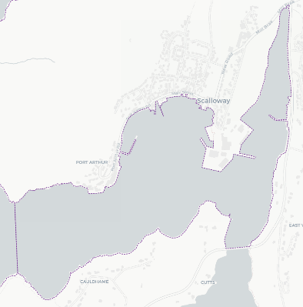
This plan provides a framework for various Harbour resources to deal with an emergency in order to minimise the impact of an emergency that occurs in the Harbour area. This is achieved by detailing how to raise the alarm, managing communication and establishing co-ordination between the various organisations and vessels involved.

This Emergency Plan is the single point of reference for all emergency or incident responses with the exception of pollution. In the event of a pollution event, this plan may be consulted, however the dedicated pollution plans should be used for the response. In the event of a security incident, the action cards in this plan should be completed and the PFSO will consult the Port Facility Security Plan.
Extent of the Blacksness (Scalloway) Harbour area as detailed in the SIC Order Confirmation Act 1979

The full document is to be used as a reference, particularly for employees assuming responsibilities under this plan. Sections, which contain action cards, may be reprinted separately to be included in ‘grab bags’ or used as check off sheets. Appropriate document control shall ensure they are updated to the current version.

Key Objectives
The Key objective of the plan is to minimise the impact of an Emergency within the Scalloway Harbour Area. This is achieved by detailing immediate actions or high priority responses and considerations to be taken by defined members of staff along with a defined communication and implementation procedure.
The priorities of this plan and all actions listed within are;
- The prevention of injury and protection of human life
- The protection and safeguarding of the marine environment
- The protection and safeguarding of property
- The protection of the Ports and the Shetland Islands Councils reputation

Implementation
The Plan may be implemented in whole or in part, depending upon the nature and scale of the incident.
This plan will be activated by the Duty Harbour Master, upon receiving and considering a report of an Emergency.
The definition of an Emergency, within this plan, is an incident affecting shipping or critical infrastructure within in the Scalloway Harbour Area, or an incident that creates, or is likely to create, a significant danger to navigation, life, property or the environment.
It may include, but not be limited to;

- Fire / Explosion on a vessel
- Damage to Port Infrastructure with threat to life
- Sinking / Capsize
- Abandon Ship
- Person in the Water (PIW)
- Pollution
- NUC/Break away
- Grounding
- Collision
- Medical Assistance
- Loss of Shipboard Navigational equipment
- Loss of Major Port Navigational Aids
- Security threats
- Bomb threats
- Protests
- IT Failure / Cyber Attack

Organisational Structure
When responding to an incident, the emergency services use an organisational structure comprised of Strategic command, Tactical command and Operational command. For continuity, this plan uses similar principles.

Roles and responsibilities
This section defines the roles and their responsibilities during an Emergency that occurs within the Scalloway Harbour Area. In the event of an Emergency, a response may be required by all or some of the following;

Category 1 Responders

The Emergency Services
The specific roles and responsibilities of each of the Emergency Services can be found on the Jesip website or by the below link
https://www.jesip.org.uk/downloads/roles-responsibilities/

Shetland Islands Council
Shetland Island Council have statutory responsibilities as a Category 1 responder and the specific actions are detailed in the SIC Major Emergency Plan.
For the sake of this plan, the SIC Responsibilities are:

- Activate and manage the SIC Major Emergency Plan as required
- Form the Corporate Management Team
- Coordinate & direct the Council wide response to the emergency
- Pass relevant information to the Scalloway Harbour Authority (SHA) Incident Management Team via the Executive Manager
- Press & media communications

Category 2 Responders

SIC as Harbour Authority for Scalloway
Will respond in two parts, the Incident Management Team (Tactical response) and SIC Response teams (Operational response).

SIC as Harbour Authority – Incident Management Team
(Tactical Response)
The Harbour Authorities Incident Management Team can consist of any of the below, but as a minimum will include the Duty Harbour Master, Duty Small Ports Officers and the Duty Port Safety.

Executive Manager
Responsibilities:
- Create SitReps
- Pass SitReps to and from the SHA Incident Management Team to Corporate Management Team and Harbour Board
- Business continuity
- Support the DHM in incident command

Duty Harbour Master
Responsibilities:
- Activate the Emergency Plan in accordance with part B of this plan
- Consult and complete appropriate Action Card(s)
- Incident command (tactical command)
- Direct SIC response teams
- Overall view of the Scalloway’s response to the incident
- Health & safety of the whole harbour area and it’s users
- Gather and pass information from the Incident Management Team to the SIC response teams.
- Pass information to the Executive Manager as appropriate
- Call in off duty staff and admin support

Duty Small Ports Officers
Responsibilities:
- Report any emergency or situation which may develop into an emergency to the Duty Harbour Master and Duty Port Safety Officer
- Once the Emergency Plan has been activated by the DHM, consult and complete the appropriate Action Card(s)
- Contributes to safety of life at sea and safety of navigation within the Scalloway Harbour area and approaches.
- Broadcast information to harbour users via VHF
- Manage port / harbour user communication of incident and support vessels, as appropriate
- Pass information between the response teams and the management team as required by the Incident Commander
- Assist Emergency Services

Off Duty Port Safety Officer / Pollution Officer
Responsibilities;
- Assist the DHM as required
- Assist in setting up Incident Room
- Track response teams throughout the incident
- Provide advice to DHM on Health & Safety / pollution
- Provide first aid as required

Engineering (ports) team leads
Responsibilities;
- Deploy staff to the Scalloway security gates as required
- Deploy staff to crew the Shearwater as required
- Deploy and liaise with Port Engineering staff as required

Support Staff
Responsibilities;
- Assist management team as required
- Provide admin support to the management team as required
- Create SitReps as requested
- Incident Log keeping
- IT support (as required)

Scalloway Harbour - SIC Response Teams (Operational Response)
The SIC response team dealing with an incident can consist of;

On Scene Commander (OSC) Afloat / Ashore
Responsibilities;
- Unless specified by the Incident Management Team, the role of the OSC Afloat may be fulfilled by the Scalloway Harbour Launch “Lyrie” and the role of the OSC Ashore shall be fulfilled by the Duty Port Safety Officer or the Small Ports Supervisor.
- Deployed on scene to provide information to the Incident Management Team
- Provide a single point of contact between the SIC Response Teams and the Incident Management Team
- Provide a single point of contact between the SIC Response Teams and Emergency services (operational response teams)

Pilots
Responsibilities;
- Provide advice to the Incident Management Team on navigational matters and local knowledge
- Provide pilotage services as required

SIC Maritime Response Teams

Harbour Launch
Responsibilities:
- Safety of crew and vessel
- Assume role of OSC afloat if first on scene
- Assist as required by the OSC Afloat if not first on scene
- Pass any relevant information to the OSC Afloat / Incident Management Team
- Respond as requested by the Incident Management Team

SIC Shore Response Teams

Engineering (Ports) staff
Responsibilities:
- Assist as required by the OSC Ashore
- Pass any relevant information to OSC Ashore

SIC Staff from other departments
Responsibilities:
- Assist as directed by the Corporate Management Team
- Once on scene, assist as required by the OSC Ashore
- Pass any relevant information to OSC Ashore

External Government Agencies
Agencies such as Maritime Security Division or the SOSREP (DfT) may get involved if the incident requires. In such a situation, the Harbour Authority must comply with any instruction given to them.

Incident Organigram
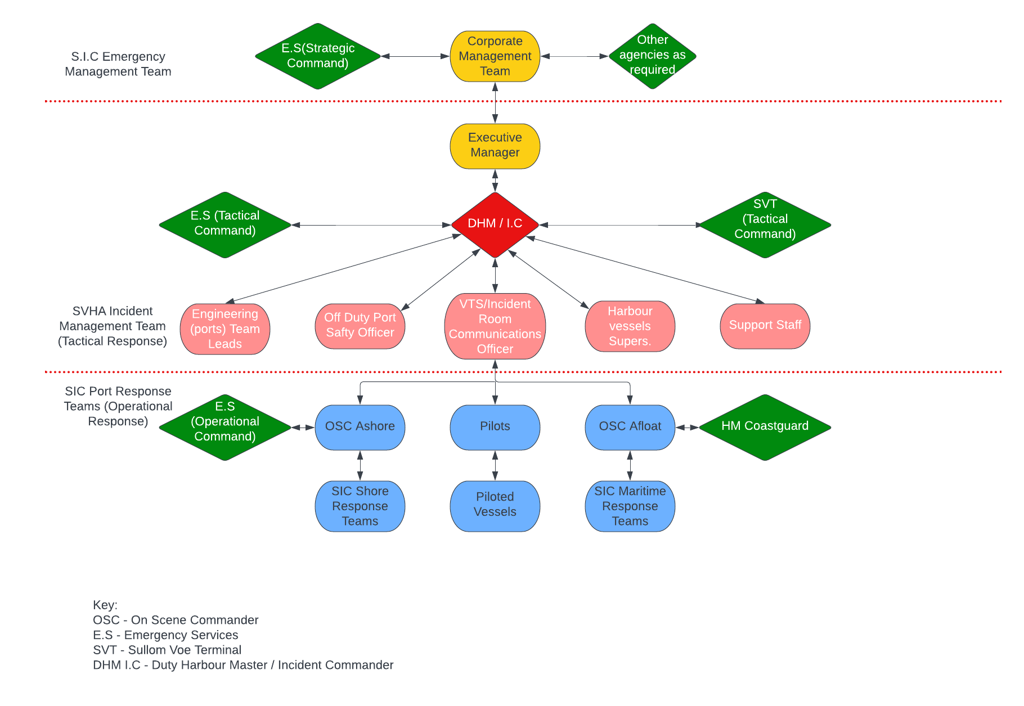

Part B

Activating the Emergency Plan
Any Emergency, or developing situation that could lead to an emergency, that occurs within the Scalloway Harbour Area, should be reported immediately to the Scalloway Harbour Office (SHO) or Sullom Voe VTS.
Upon receipt of such a report, the Duty Harbour Master shall be called. A Decision Support System for SHO/ VTS on when to call the DHM can be found in this section.
Once the Duty Harbour Master has been contacted, they can make a decision as to whether to activate the Emergency Plan. A Decision Support System on when the Duty Harbour Master should activate the Emergency Plan can also be found later in this section.

Notification that the plan has been activated
If the decision is made to activate the plan, the Duty Harbour Master can confirm this decision by any means appropriate. The decision to activate the plan shall be communicated to all relevant personnel.
The Action cards in part C for SHO, DHM and Executive manager detail who to call when the plan has been activated. These call outs should be made ASAP stating clearly that the Scalloway Harbour Emergency Plan has been activated.

SHO / VTS – Decision Support System - When to call the DHM
See below flow chart for when SHO/VTS should call the DHM
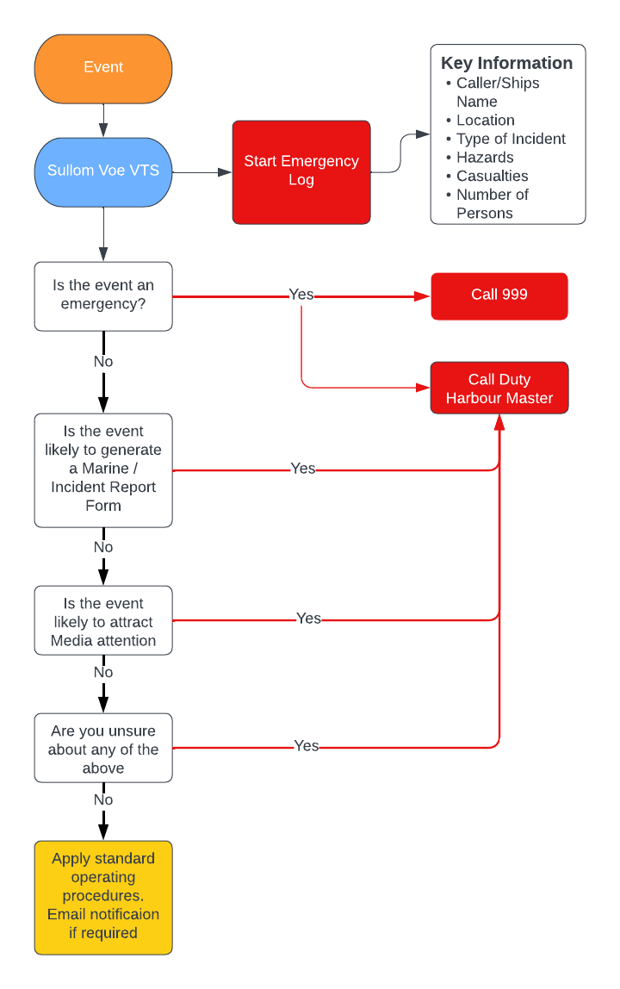

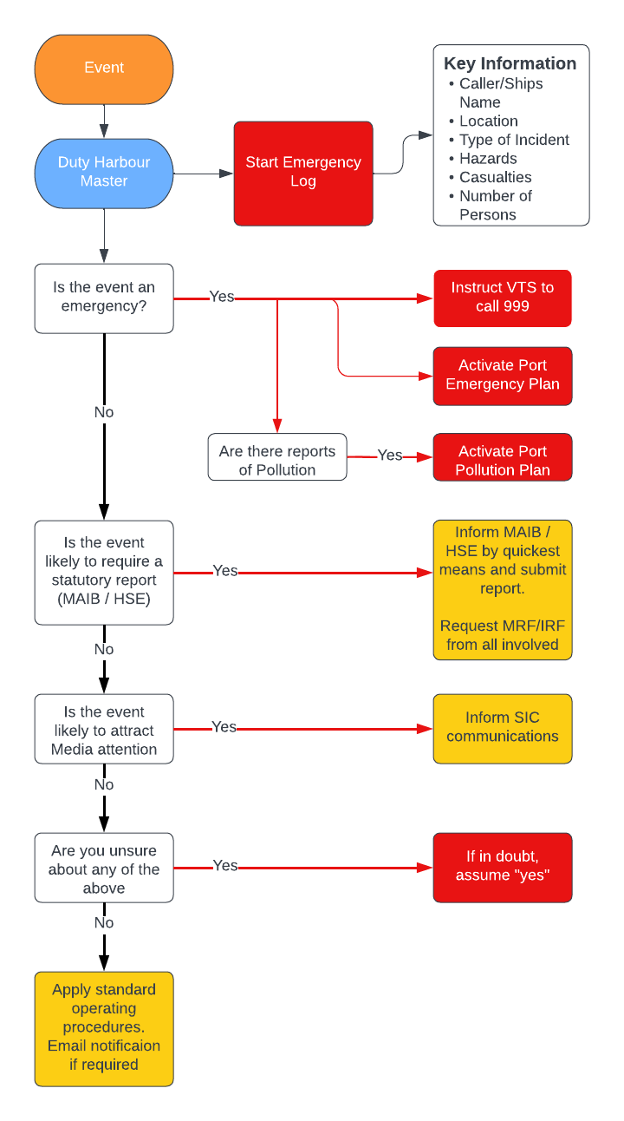DHM – Decision support system – When to activate the Emergency Plan

Communication

Contact Sheet
SIC Chief Executive’s Department
Chief Executive & Corporate Management Team | Contact through Emergency Planning
Emergency Planning & Resilience  Ingrid Gall | Work  Mobile | 01595744740  07831306124
Director of Infrastructure  John Smith | Work  Mobile | 01595 744723  07766421002

SIC Ports & Harbours
Executive Manager – Harbour Master  Ross Gordon | Work  Mobile | 01806 244202  07543822595
Team Lead – Deputy Harbour Master  James Milne | Work  Mobile | 01806244245  07385428532
Team Lead – Deputy Harbour Master  Vacant | Work  Mobile
Team Lead – Fleet Engineering  David Hopwood | Work  Mobile | 01806 244205  07739 403907
Team Lead – Fleet  Kevin Main | Work  Mobile | 01806 244297  07795 272053
Port Safety Officer  Vacant | Work  Mobile
Port Safety Officer  Vacant | Work  Mobile
Sullom Voe VTS | VHF Ch.  Phone  Mobile | 14 / 10  01595744280  07384878711
Scalloway Harbour Office | VHF Ch.  Phone | 14  01595744221

SVHA Incident Control Room
Communications Officer | Phone  VHF | 01595807000  10

SIC Ports Engineering
Executive Manager – Marine Infrastructure & Airports  Andrew Inkster | Work  Home  Mobile | 01806 244264  01595 840538  07747 620456
Team Leader – Ports Engineering  Claire Christey | Work  Home  Mobile | 01806244203
SIC ICT | Duty phone | 0159574777

Emergency Services
HM Coastguard | VHF Ch.  Phone | 16  999
Police Scotland | Phone  Phone (non-emergency) | 999  101
Highlands & Islands Fire Service | Phone | 999
Scottish Ambulance Service | Phone | 999

Sullom Voe Terminal
SVT ERB | Phone  Phone | 01806 243366  01806 242797
SVT IMT | Phone | 01806 243560

Notifications
When making initial calls to Port Staff or the Emergency Services, the information and format used should be to the M.E.T.H.A.N.E format shown below. This is widely used by the Emergency Services and for unity SVHA have adopted the same format.

*Definition of a Major Incident
“A major incident is beyond the scope of business-as-usual operations, and is likely to involve serious harm, damage, disruption or risk to human life or welfare, essential services, the environment or national security” (https://www.jesip.org.uk/uploads/media/app/Jesip-web-version/major.html)

Lines of Communication

Communication between the Incident Management Team
and the SIC Response Teams
The On Scene Commander Ashore shall provide a single point of contact between the Incident Management Team and the SIC Shore Response Teams.
The On Scene Commander Afloat shall provide a single point of contact between the Incident Management Team and the SIC Maritime Response Teams

Prior to the Scalloway incident room being established
Until the Incident Room has been established, communications between the Incident Management Team and the SIC Response teams shall be passed through the Scalloway Harbour Office or Sullom Voe VTS.

Establishing Communications in the Incident Room
Once the Incident Management Team and Incident Management Room have been established, the Incident Commander may take emergency communications into the Incident Room.
To do this;
- Establish the room with defined roles for each staff member
- Allocate an appropriate staff member to be radio operator (if possible, use an off duty VTSO)
- Test radio equipment & set to VHF Ch. 10
- Inform SHO\VTS that the incident room now has the watch on VHF Ch. 10.
- SHO\VTS will then revert to routine working and will assist as required.

If deemed appropriate to the situation, the Incident Commander may decide not to take radio communications into the Incident Room. In this case, communications between the Incident Management team and the SIC Response Teams shall continue to be passed through the Scalloway Harbour Office.

After the Incident Room has been established
If the Incident Room takes over emergency communications, then information shall be passed to/from the SIC Response Teams directly to/from the Incident Room Radio Operator either via VHF or telephone.

Communication between the SHA Incident Management Team
and the Shetland Islands Council
The Executive Manager in the Incident Management Team, shall liaise with the Corporate Management Team. Contact with the Corporate Management Team to be made through the Emergency Planning and Resilience Officer.
If other council departments are to be utilised in the response, the request shall be made through the Executive Manager within the Incident Management Team, to the Corporate Management Team.
If Corporate Management Team has not been established, the Executive Manger in the Incident Management Team shall liaise directly with the Director of Infrastructure Services.

Communication between the SIC and Emergency services

Emergency Services – Strategic Command
All communications to the Emergency Services Strategic Command shall be made through the SIC Corporate Management Team.

Emergency Services – Tactical Command
A SIC representative may be requested to attend the Emergency Services Tactical Command Centre. If not specifically requested, the SVHA should consider if it is appropriate to request for either a SIC representative to be present in the Emergency Services Tactical Command Centre, or for Emergency Service Representatives to be present in the SVHA Incident Control Room.
If a SIC representative is to be deployed to the Emergency Services Tactical Command Centre, where possible, this role should be filled by the off duty Harbour Master or the SVHA Incident Management Team Executive Manager.

Emergency Service – Operational Command
The On Scene Commander Ashore shall liaise with the operational command of the Emergency Services.
If HM Coastguard are coordinating the maritime response, the On Scene Commander Afloat shall provide a single point of contact between the Harbour Vessels and the HM Coastguard

Communication with Duty Counter Pollution and Salvage Officer (DCPSO) & SOSREP
The DCPSO & SOSREP will be contacted by the local coastguard station if deemed necessary. In the event that the SOSREP becomes involved, the Harbour Authority must comply with all instructions given by SOSREP. If this happens, the Duty Harbour Master shall confirm that SOSREP is taking responsibility, including financial responsibility, for the decisions being made. This shall be recorded in the Duty Harbour Master’s incident log.

Communication with Casualty Vessels
Where possible, casualty vessels should communicate directly with the emergency services.
Where communication between a casualty vessel and the SHA is required, the communication shall be passed through the Scalloway Harbour Office. Any information from the casualty vessel, shall be shared to all responders through the lines of communication detailed within this plan.

Communication with the Media
Press releases shall be issued by the Corporate Management Team in consultation with the SVHA Incident Management Team – Executive Manager. If the Major Emergency Plan has not been activated, press releases shall be issued by the Executive Manager within the Incident Management Team, in consultation with SIC Communications.
Any other member of staff approached by the media or public for information, should refer to the press holding statement below. This statement can also be found in Part C of this Plan.
Statement
“Scalloway Harbour Authority is currently dealing with an incident which has occurred within the Scalloway Harbour Limits. The Scalloway Harbour Emergency Plan has been activated and response teams are in attendance.
A full press release will be made shortly.
For any further information please contact the Shetland Islands Council Media and Communications department.”

Communication with Protesters
In the event of a protest at the Harbour Authority Office, the PFSO shall address protesters with the following statement and questions
Statement
“This Fence line and gates mark the boundary of a restricted area. Crossing this boundary unauthorised, constitutes an offence under the Ship and Port Facility Regulations (2004). Any person in breach of these regulations, will be charged.
This area is monitored by CCTV. Any person involved in any criminal activity will be charged
For your own safety, I ask that you conduct your protest off of the road and at a safe distance from passing vehicles
Restricting access or egress to or from this area, may have a detrimental effect on any response in the event of a pollution or emergency event.”

Methods of Communication
Methods of communication during an incident shall be by any means deemed appropriate and can include but not be limited to
- Telephone
- Mobile phone / Apps / Electronic media
- VHF
- Email
- Runners / Verbal

Methods of Communication - Contingencies
The following shall be applied in the event of the plan being activated during a major communications outage involving telephone and mobile network failure.
Communications during a telephone and network outage shall be by any means deemed appropriate. The below should be used as a guide.

Call out / Notifications to Emergency Services
If a response is required from the Emergency Services, Scalloway Harbour Office shall contact HMCG via VHF Ch. 16.

Call out / Notifications to Scalloway harbour
Communications to Scalloway Harbour Office shall be via VHF Ch. 14

Communications during an incident to/from the SHA Incident Management Team
- Communications to / from Harbour vessels shall be by VHF radio.
- Communications to / from shore teams shall be by portable hand held VHF radios

Situation Reporting
SitReps are a means of passing information from one person or team to another. They can be passed
- verbally in person,
- over the phone,
- over VHF
- via email

SitReps shall be created and passed on whenever there is a change in situation or at regular intervals to report no change. When SitReps are made, they shall be passed as per the Lines of Communication detailed in this section and shall be recorded using the format found in Annex III

Mobilisation

Mobilisation of SIC Incident Management Team (Tactical Response)
Unless otherwise specified, the SIC Incident Management Team shall mobilise in the Incident Control Room located in the Port Administration Building. The Incident Commander may mobilise the Incident Management Team to any other location deemed appropriate for the scope of the incident. Consideration should be given to mobilising in SHO/VTS, particularly when staff resources are stretched.
The minimum staff required in order to establish the incident management team shall be
- The Incident Commander
- The Duty SPO/VTSO
- The Duty Port Safety Officer (who will assume the role of On Scene Commander Ashore as required)
Where the Incident Management Team is made up of only the minimum staff listed above, or where support staff are not available to keep an incident log, the Incident Management Team shall mobilise in SHO/VTS. If Sullom Voe VTS is used it will ensure that all communications in/out of the Incident Management Team are automatically recorded.

Co-Locating
Where Category 1 Responders are responding to an incident, Tactical and Strategic Incident Commanders may co-locate. If this happens, the SHA may be requested to co-locate to an incident command centre, set up by a Category 1 responder. If requested to co-locate, SHA shall cooperate and send a representative of the SHA. Where possible this should either be the SHA Incident Commander or the SHA Executive Manager.
If Category 1 Responders set up a joint command centre but SHA are not requested co-locate, consideration should be given as to whether it would be appropriate or beneficial to request SHA attendance at the joint command centre.

Mobilisation of SIC Response Teams (Operational Response)
Where SIC Response Team staff are called in to mobilise, they shall report to their usual place of work.
Shore Teams shall be made up of a minimum of 2 persons and a maximum of 5. Each Shore Team shall have a Team Leader appointed to them. Each Team Leader shall collect a portable VHF radio and establish communications with the On Scene Commander Ashore.
Once mobilised, SIC Response Teams shall report to either the On Scene Commander Ashore, or the On Scene Commander Afloat as appropriate. The On Scene Commander Ashore / Afloat shall inform the Incident Management Team that the SIC Response Team is mobilised and standing by.

Rendezvous Point / Muster Point
The Rendezvous Point (RVP) for the emergency services / Muster point (MP) for Scalloway staff, unless specified otherwise, shall be the car park immediately in front of the Scalloway Harbour Office.
The SHA “On Scene Commander Ashore” shall meet the Emergency Services at the RVP (or other specified area) and relay information to / from the SHA Incident Management Team.

Access to the RVP / MP
- LAT / LONG 60° 26.69’N 001° 16.63’W
- What3Word reference Marzipan.faced.saints
- Access is via a security gate which may be locked and staffed
- Good parking is available at this disused car park
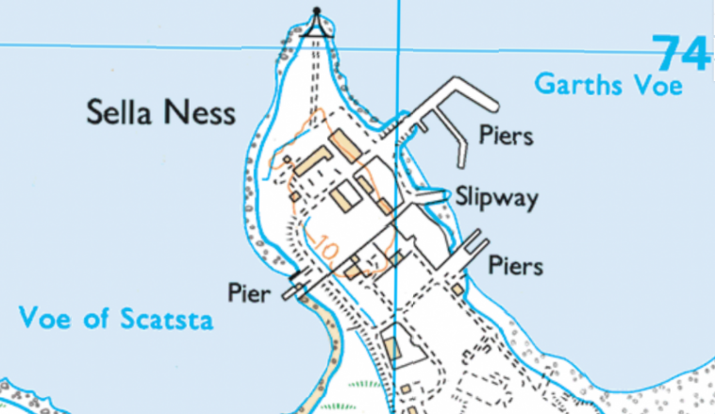
RVP / MP

Landing Points
There are 7 piers or slipways owned and operated by the SVHA within the Sullom Voe Harbour Area, any of which could act as landing points for casualties or as forward command centres for the response teams. For casualties in stretchers, the most suitable landing point is the Sella Ness Pilot Launch Pontoon.
- Collifirth Pier
- Construction Jetty
- Sella Ness Tug Jetty
- Sella Ness Pilot Launch Pontoon
- Sella Ness Slipway
- Garths Pier
- Toft Pier
In addition to the above, the below piers are located within the Sullom Voe Harbour Area but are not owned, operated or maintained by SVHA.
- Mossbank Pier
- McKimm’s slipway
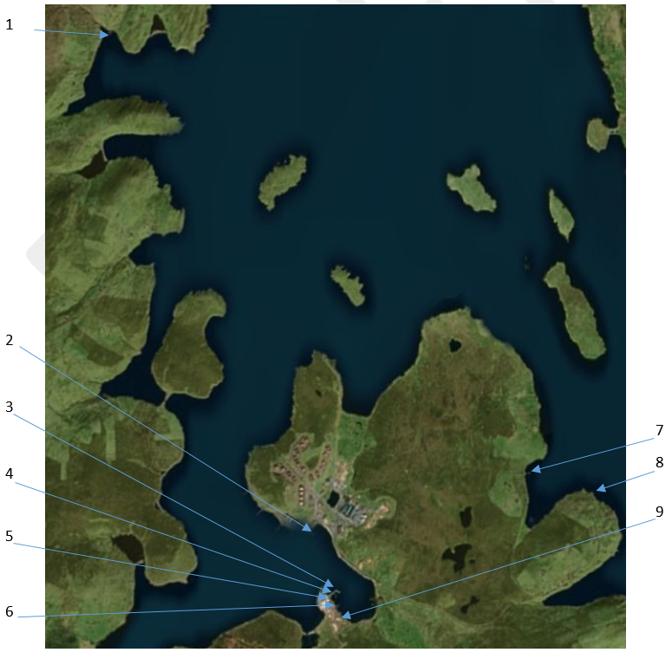

Access to Landing Points

Collifirth Pier
- LAT / LONG 60°32.43’N 001°20.94’W
- What3Words reference is “reference.bongo.tram”
- Access is unrestricted with no security gates or barriers
- Lay down area immediately to the north of the pier provides good parking

The Construction Jetty
- LAT / LONG 60° 27.41’N 001° 16.93’W
- What3Words reference is “acrobat.titles.grocers”
- Access is via a security barrier which may be locked and staffed
- The pier and adjacent lay down area provide good parking for emergency vehicles

Sella Ness Tug Jetty
- LAT / LONG 60°26.82’N 001°16.42’W
- What3Words reference is “blink.correctly.called”
- Access is via a security gate at the entrance to Sella Ness which may be locked and staffed
- Parking is limited on the tug Jetty however good parking is available outside the Port admin buildings

Sella Ness Pilot Launch Pontoon
- LAT / LONG 60°26.78’N 001°16.40’W
- What3Words reference is “intruded.using.dwarf”
- Access is via a security gate at the entrance to Sella Ness which may be locked and staffed, then towards the Sella Ness Tug Jetty and down a narrow finger pier
- Parking is limited on the finger pier

Sella Ness Slipway
- LAT / LONG 60°26.73’N 001°16.45’W
- What3Words reference is “zapped.prune.haggle”
- Access is via a security gate at the entrance to Sella Ness which may be locked and staffed
- Parking is Limited at the slipway but good parking is available outside the Port Admin Buildings

Garths Pier
- LAT / LONG 60°26.66’N 001°16.40’W
- What3Words reference is “porridge.leap.magazines”
- Access is unrestricted with no security gates or barriers
- Area at the root of the pier provides good parking

Toft Pier
- LAT / LONG 60° 28.00’N 001° 12.46’W
- What3Words reference is “hoofs.duties.fuse”
- Access is unrestricted with no security gates or barriers
- Parking may be limited with occasional heavy traffic from the Yell Ferry

Mossbank Pier
- LAT / LONG 60° 27.72’N 001° 10.93’W
- What3Words reference is “caged.comically.nourished”
- Access is unrestricted with no security gates or barriers
- Good parking is available at the root of the pier and immediately to the West.

McKimms Slipway
- LAT / LONG 60° 26.55’N 001° 16.21’W
- What3Words reference is “informer.postage.couches”
- Access is via the McKimm’s compound and a locked security gate. Security is controlled by McKimm Ltd.
- Good parking is available throughout the McKimm’s compound.

Deployment

Deployment of SIC Response Teams
Prior to deploying any of the SIC Response Teams, the Incident Management Team shall consider any potential danger and the overall risk to the SIC Response Team(s). In considering the risk, the Incident Management Team shall consult with the On-Scene Commander Afloat / Ashore.
SIC Response Teams shall only be deployed when the Incident Management Team and the On-Scene Commander Afloat / Ashore are in agreement that it is safe to do so.

On Scene Commander Afloat / Ashore
Unless specified by the Incident Management Team, the Scalloway Harbour launch shall fulfil the role of the On Scene Commander Afloat and the Duty Port Safety Officer shall fulfil the role of On Scene Commander Ashore.
They may be deployed at an early stage to provide eyes on the scene and to provide information to the Incident Management Team but they must remain at a safe distance and not enter any exclusion zone, until the relevant action cards and checklists have been completed.

Deployment of all other Harbour Vessels
The Master of any vessel being used as part of the SIC Response Teams remains responsible for the safety of their vessel and crew.
No instruction given under this plan shall overrule the authority of the Master to refuse any instruction, if they believe it to be unsafe.
A Harbour Vessel being deployed under this plan, shall complete all action cards / checklists appropriate to the scope of the emergency, prior to deployment.

Deployment of SIC Shore Teams
Each Team Leader shall complete all action cards / checklists appropriate to the scope of the emergency, prior to their team being deployed.
The Team Leader is responsible of the overall safety of their team.
Each member of the team remains individually responsible for their own safety and that of those working with and around them, so that no one puts any other person at risk.

Standing Down
When de-activating this plan and standing down from an emergency, the following shall apply
- An Emergency which has involved the Emergency Services, may only be declared over by the Emergency services.
- An area or workspace that has been evacuated due to the emergency, may only be declared as safe, by the Emergency Services
- An area or workspace that has been evacuated during the emergency, may only be re-entered after being declared safe by the Emergency Services.
- This plan should only be de-activated by the Incident Commander.
- Once the emergency has been declared as over and the Incident Commander has de-activated this plan, it shall be clearly communicated through the same lines of communication as detailed within this plan.
- Incident Commander to ensure that all paperwork and electronic logs are collected and collated
- A debrief and review shall be organised as below.

Debriefing & Review
The objectives of any De-brief are to discuss;
- What happened
- What went well
- What could be improved

The debrief should include as many persons as possible who were involved in the incident. It does not form part of the investigation, nor is it a means of apportioning blame or finding fault with the way that the incident was managed.

Any incident has the potential to have a lasting effect on those who are involved, whether they suffer physical injury as a direct result and/or mentally after they event due to what they have witnessed and been required to respond to as part of their job role.

An incident debrief, informal or formal, is a means to provide all persons involved from across all agencies with the option to discuss the incident. It should be carried out in order to mitigate the effects of any trauma those involved in the incident have experienced.

The debrief is an open forum for discussion, there should be no judgement and where the incident has been particularly serious it should be facilitated by the Staff Welfare Officer or a similarly trained individual. The debrief is part of the incident recovery for staff who have experienced a distressing or traumatic event and a means for those who wish to seek additional support to be reminded of where and how that can be accessed.

In order to be most effective the debrief should be carried out 24 – 72 hours after the event, giving staff time to seek one to one support if they want it and providing those involved with time to digest what occurred and what the outcome of the incident has been.

Points for improvement should be recorded for use during the review of the plan.

Incident De-brief Procedure
The below diagram shows the procedure an incident de-brief should follow in order to be most effective.

Review and Amendments
The Emergency Plan shall be viewed as an active document that is allowed to develop and evolve in order to ensure that it is kept current.

Review Process
Reviews shall be carried out by the Harbour Master or their Deputies. The reviewed document along with any amendments shall be submitted for comment, to a panel made up of;
- Director of Infrastructure
- Executive Manager – Harbourmaster
- Executive Manager – Ferry & Airport Operations & Port Infrastructure
- Deputy Harbour Master(s)
- Port Safety Officer(s)
- Small Ports Supervisor (Or nominated member of Scalloway Harbour staff)
- Engineering (Ports) Team Lead
- Fleet Team Lead(s)
- A VTS Representative
- A Pilot Representative
- Emergency Service representatives

The quorum for the review panel shall be 4 members.

Once the panel have approved any amendments, the draft shall be submitted to the full distribution list for comment.

It should be noted that amendments are controlled documents and once approved and enacted will be issued to each holder of the Emergency Plan. A log of the amendments are listed in the appendices.

Training and Exercise
This plan shall be exercised as follows,
- A Multi agency exercise at intervals not exceeding 1 year – as a minimum this shall include SVHA & SVT
- An internal drill at intervals not exceeding 2 months – as a minimum this shall include the Duty Harbour Master and the Small Ports Supervisor (Or nominated member of Scalloway Harbour staff)

When arranging exercises, especially in regards to multi agency exercises, consideration should be given to the arranging, execution and debriefing of the exercise.
A guide to exercise planning can be found in the link below
https://ready.scot/how-scotland-prepares/preparing-scotland-guidance/exercise-guidance

Reasons for Review
The Emergency Plan will be reviewed at a period not exceeding three years as a matter of routine or “with cause” – examples of which are listed below;

- Additional or changes to the events that the emergency plan is designed to manage
- Update to information and methods used
- Changes to legislation
- Changes in personnel, staffing numbers or resource availability
- Lessons learnt from implementing the emergency plan in an exercise or event
- On receipt of an amendment request
- Lessons learnt from other emergency events in similar working environments

Part C

Action Cards

Incident Action Cards
- Fire/Explosion on a Vessel
- Damage to Port Infrastructure with threat to life
- Sinking / Capsize
- Abandon Ship
- PIW
- Pollution
- NUC / Breakaway
- Grounding
- Collision
- Medical Assistance
- Loss of Shipboard Navigational Equipment
- Loss of VTS / Major Port Nav aids
- Security Threat
- Bomb Threat
- Protest
- IT failure / Cyber attack

Marine Exclusion Zone Action Cards
- Scalloway Harbour Exclusion zone pro forma
- Scalloway Harbour Flowchart – Vessels entering an exclusion zone

SIC Shore response team Action Card
- All Scenarios

Executive Manager Action Card
- All Scenarios

Contact Sheet
SIC Chief Executive’s Department
Chief Executive & Corporate Management Team | Contact through Emergency Planning
Emergency Planning & Resilience  Ingrid Gall | Work  Mobile | 01595744740  07831306124
Director of Infrastructure  John Smith | Work  Mobile | 01595 744723  07766421002

SIC Ports & Harbours
Executive Manager – Harbour Master  Greg Maitland | Work  Mobile | 01806 244209  07392 120713
Team Lead – Deputy Harbour Master  Ben Clifton | Work  Mobile | 01806244245  07385428532
Team Lead – Deputy Harbour Master  Ross Gordon | Work  Mobile | 01806 244202  07543822595
Team Lead – Fleet Engineering  David Hopwood | Work  Mobile | 01806 244205  07739 403907
Team Lead – Fleet  Kevin Main | Work  Mobile | 01806 244297  07795 272053
Port Safety Officer  Simon Skinner | Work  Mobile | 01806 244277  07769 911000
Port Safety Officer  Jane Evans | Work  Mobile | 01806244278  07584635640
Sullom Voe VTS | VHF Ch.  Phone  Mobile | 14 / 10  01595744280  07384878711
Scalloway Harbour Office | VHF Ch.  Phone | 14  01595744221

SVHA Incident Control Room
Communications Officer | Phone  VHF | 01595807000  10

SIC Ports Engineering
Executive Manager – Marine Infrastructure & Airports  Andrew Inkster | Work  Home  Mobile | 01806 244264  01595 840538  07747 620456
Team Leader – Ports Engineering  Claire Christey | Work  Home  Mobile | 01806244203
SIC ICT | Duty phone | 0159574777

Emergency Services
HM Coastguard | VHF Ch.  Phone | 16  999
Police Scotland | Phone  Phone (non-emergency) | 999  101
Highlands & Islands Fire Service | Phone | 999
Scottish Ambulance Service | Phone | 999

Sullom Voe Terminal
SVT ERB | Phone  Phone | 01806 243366  01806 242797
SVT IMT | Phone | 01806 243560

Action Card Numbering

1 Fire
2 Damage to Port Infrastructure
3 Sinking & Capsize
4 Abandon Ship
5 Person In Water
6 Pollution
7 NUC/Breakaway
8 Grounding
9 Collision/Allision
10 Medical Assistance
11 Loss of Shipboard Navigation
12 Loss of VTS
13 Security Threat
14 Bomb Threat
15 Protest
16 IT Failure/Cyber Attack
17 Marine Exclusion Zone
18 Shore Team Response
19 Executive Manager Response
20 Spare

Fire/Explosion on a vessel
- DHM Action Card
- Small Ports Officer Action Card
- Duty Safety Officer Action Card
- Off Duty Safety Officer Action Card

Fire / Explosion on a Vessel | Action Card: DHM
Task |  | Notes
Start new Incident Log
Obtain information from Scalloway Harbour Office or VTS
Activate Emergency Plan in accordance with Part B
Is safe for Scalloway duty Launch to proceed
Sullom Voe - Duty tug / Launch to call in stand by crews
Is safe for duty Tug to proceed
Make harbour vessels available to assist as required
Call Executive Manager (EM)
Call Port & Marine Super.
Call Tug Engineering Super.
Call duty Pilots
Call off duty VTSOs
Call Port Engineering Team Lead
Call for Admin & IT support
Assign SHO-ICR communications officer (if required)
Assess whether an exclusion zone is required
Assess danger to the port and other users
Consider Port Closure & Gates
If Pollution is reported, activate the pollution plan
Liaise with Emergency Services
Call MAIB and PSC
Responsibilities: | - Assess the need to activate the Emergency Plan  - Incident Command  - Health and Safety of the response  - Communicate with Response teams and the EM

Responsibilities: | - Assist Emergency Services  - Ensure safety of other vessels in the area
Fire/Explosion on a Vessel | Action Card: Small Ports Officer

Task |  | Notes
Start new Incident Log
Obtain Information
- Name & Position of Vessel
- Type of ship & Cargo
- Are there LNG tanks on deck
- Is the ship NUC
- How many Persons on Board
- Are there any Casualties
- Have they contacted the Coastguard
Advise casualty vessel to call the Coastguard
Alert any available harbour craft if within harbour area
If utilised, advise harbour craft to contact Coastguard
Call emergency services to confirm they are aware of the incident
Inform Sullom Voe VTS
Call Duty Harbour Master
Call Duty Port Safety Officer
Call first duty Pilot
Inform all Vessels in the Area
Upon arrival of DHM, pass on all relevant information
Standby to pass information between Response teams & DHM
Continue to monitor traffic in the area and provide traffic / navigation information

Fire/Explosion on a Vessel | Action Card: Duty Port Safety Officer

Responsibilities: | - On Scene Commander  - Communicate with Incident Control Room  - On Scene Casualty Care
Task |  | Notes
Obtain information from SHO /DHM
Assist DHM as requested
Deploy to Scene
Assess Situation on Arrival
Receive Update from Person(s) on site
Feedback to SHO/DHM
Provide SitRep to Incident Control Room
Provide reception at RVP
Nominate contact for Emergency Services at RVP
If Pollution is reported, respond as per Pollution Plan
Provide briefing to persons attending regarding on site hazards and action required
Provide on scene casualty care as required

Fire/Explosion on a Vessel | Action Card: Port Safety Officer
Task |  | Notes
Obtain information from SHO/DHM
Assist DHM as requested
On Activation of Emergency Plan Set up Incident Room (In Scalloway or Sella Ness as directed by DHM)
Set up Asset Board and manage accordingly as assets are deployed, redeployed and stood down
Provide casualty/ambulance reception at Scalloway Harbour
If Pollution is reported, respond as per Pollution Plan
Record SitRep from On Scene Commander
Pass information between On Scene Commander and Incident Room
Collate MRF and PIN Forms as appropriate
Collect, preserve and document evidence.

Responsibilities: | - Activate the Incident Control Room  - Assist DHM  - Health and Safety Advice

Damage to Port Infrastructure with threat to life
- DHM Action Card
- Small Ports Officer Action Card
- Small Ports Officer Action Card – Evacuation of SHO
- SHO Suspended pro forma
- Duty Safety Officer Action Card
- Off Duty Safety Officer Action Card

Damage to Port Infrastructure with Threat to Life | Action Card: DHM
Responsibilities: | - Assess the need to activate the Emergency Plan  - Incident Command  - Health and Safety of the response  - Communicate with Response teams and the EM
Task |  | Notes
Start new Incident Log
Obtain information from SHO
Activate Emergency Plan in accordance with Part B
If in danger, evacuate immediately
Proceed to Muster Point
Follow instructions given by the fire marshal or emergency services
Consider danger to Harbour Vessels (consider alternative berths for them)
Make harbour vessels available to assist as required
Inform Sullom Voe VTS
Call Executive Manager
Call Port & Marine Super.
Call Tug Engineering Super.
Call off duty VTSOs
Call Port Engineering Team Lead
Call for Admin support
Assess danger to all port users
Assess whether an exclusion zone is required
Consider Port Closure & Gates
If SHO is unavailable, consider use of a Harbour Launch “Lyrie” to broadcast exclusion zone details
Liaise with Emergency Services

Damage to Port Infrastructure with Threat to Life | Action Card:  Small Ports Officer(s)

Task |  | Notes
Start new Incident Log
If in danger, evacuate immediately and follow action card “Evacuation of SHO”
Call 999
Alert duty harbour vessels
Call Duty Harbour Master
Call Duty Port Safety Officer
Call Sullom Voe VTS
If Exclusion zones are implemented, follow Action card “Exclusion zone Pro-Forma”
Upon arrival of DHM, pass on all relevant information
Standby to pass information between Response teams & DHM
Continue to monitor traffic in the area and provide traffic / navigation information
Responsibilities: | - Assist Emergency Services  - Ensure safety of other vessels in the area  - Maintain VTS Services

Evacuation of Scalloway Harbour Office | Action Card:  Small Ports Officer(s)

Responsibilities: | - Own safety  - Where possible continue to communicate with vessels.

Task |  | Notes
If in danger, leave the building Immediately
If safe to do so, proceed to Harbour Launch
Issue VHF broadcast from Harbour Launch with information “SHO unavailable Call Duty Launch for further information”
If unsafe to proceed to Harbour Launch, proceed to muster point
Call Duty Harbour Master
Call Sullom Voe VTS
Upon arrival of DHM, pass on all relevant information
Continue to communicate with vessels via VHF where possible. Provide information that VTS is Suspended

SHO Suspended - ProForma | Small Ports Officer(s)

In the event that SHO is unavailable, the following message shall be broadcast on VHF Ch.14 by the Small Ports officer(s) via the Harbour Launch VHF radio.
If the VTSO is unable to broadcast the below, the below shall be broadcast by the Duty Tug
“Sécurité, Sécurité, Sécurité
All Ships, All Ships, All Ships,
This is Scalloway Harbour launch “Insert Name” .
Information
Scalloway Harbour Radio is suspended until further notice.
This is Scalloway Harbour launch Lyrie, Out”
Damage to Port Infrastructure with Threat to Life | Action Card: Duty Port Safety Officer

Responsibilities: | - On Scene Commander  - Communicate with Incident Control Room  - On Scene Casualty Care
Task |  | Notes
Obtain information from SHO/DHM
Assist DHM as requested
Deploy to Scene
Assess Situation on Arrival
Receive Update from Person(s) on site
Feedback to SHO/DHM
Provide SitRep to Incident Control Room
Provide reception at RVP
Nominate contact for Emergency Services at RVP
If Pollution is reported, respond as per Pollution Plan
Provide briefing to persons attending regarding on site hazards and action required
Provide on scene casualty care as required

Damage to Port Infrastructure with Threat to Life | Action Card: Port Safety Officer
Task |  | Notes
Obtain information from SHO/DHM
Assist DHM as requested
On Activation of Emergency Plan Set up Incident Room (In Scalloway or Sella Ness as directed by DHM)
Set up Asset Board and manage accordingly as assets are deployed, redeployed and stood down
Provide casualty/ambulance reception at Scalloway Harbour
If Pollution is reported, respond as per Pollution Plan
Record SitRep from On Scene Commander
Pass information between On Scene Commander and Incident Room
Collate MRF and PIN Forms as appropriate
Collect, preserve and document evidence.

Responsibilities: | - Activate the Incident Control Room  - Assist DHM  - Health and Safety Advice

Sinking / Capsize
- DHM Action Card
- Small Ports Officer Action Card
- Duty Port Safety Officer Action Card
- Off Duty Port Safety Officer Action Card

Sinking / Capsize | Action Card: DHM
Responsibilities: | - Assess the need to activate the Emergency Plan  - Incident Command  - Health and Safety of the response  - Communicate with Response teams and the EM
Task |  | Notes
Start new Incident Log
Obtain information from SHO
Activate Emergency Plan in accordance with Part B
Is safe for duty Launch (“Lyrie”) to proceed
Sullom Voe - Duty tug / Launch to call in stand by crews
Is safe for duty Tug to proceed
Make harbour vessels available to assist as required
Inform Sullom Voe VTS
Call Executive Manager
Call Port & Marine Super.
Call Tug Engineering Super.
Call duty Pilots
Call off duty VTSOs
Call Port Engineering Team Lead
Call for Admin support
Assign ICR communications officer (if required)
Assess whether an exclusion zone is required
Assess danger to the port and other users
Consider Port Closure & Gates
If Pollution is reported, activate the pollution plan
Liaise with Emergency Services
Call MAIB and PSC

Sinking / Capsize | Action Card: Small Ports Officer
Responsibilities: | - Assist Emergency Services  - Ensure safety of other vessels in the area  - Maintain VTS Services

Task |  | Notes
Start new Incident Log
Obtain Information
- Name & Position of vessel
- Are they abandoning ship
- Are there Persons in the Water
- Are there any casualties
- Have they called the Coastguard

Advise casualty vessel to call the Coastguard
Alert any available harbour vessels if within harbour area
If utilised, advise harbour vessel to call the Coastguard
Call Duty Harbour Master
Call emergency services to confirm they are aware of the incident
Call Duty Port Safety Officer
Call first duty Pilot
Inform all Vessels in the Area
Inform Sullom Voe VTS
Upon arrival of DHM, pass on all relevant information
Pass information between response teams and DHM
Continue to monitor traffic in the area and provide traffic / navigation information

Sinking / Capsize | Action Card: Duty Port Safety Officer

Responsibilities: | - On Scene Commander  - Communicate with Incident Control Room  - On Scene Casualty Care
Task |  | Notes
Obtain information from SHO/DHM
Assist DHM as requested
Deploy to Scene
Assess Situation on Arrival
Receive Update from Person(s) on site
Feedback to SHO/DHM
Provide SitRep to Incident Control Room
Provide reception at RVP
Nominate contact for Emergency Services at RVP
If Pollution is reported, respond as per Pollution Plan
Provide briefing to persons attending regarding on site hazards and action required
Provide on scene casualty care as required

Sinking / Capsize | Action Card: Port Safety Officer
Task |  | Notes
Obtain information from SHO/DHM
Assist DHM as requested
On Activation of Emergency Plan Set up Incident Room (In Scalloway or Sella Ness as directed by DHM)
Set up Asset Board and manage accordingly as assets are deployed, redeployed and stood down
Provide casualty/ambulance reception at Scalloway Harbour
If Pollution is reported, respond as per Pollution Plan
Record SitRep from On Scene Commander
Pass information between On Scene Commander and Incident Room
Collate MRF and PIN Forms as appropriate
Collect, preserve and document evidence.
Responsibilities: | - Activate the Incident Control Room  - Assist DHM  - Health and Safety Advice

Abandon Ship
- DHM Action Card
- Small Ports Officer Action Card
- Duty Port Safety Officer Action Card
- Off Duty Port Safety Officer Action Card

Abandon Ship | Action Card: DHM
Responsibilities: | - Assess the need to activate the Emergency Plan  - Incident Command  - Health and Safety of the response  - Communicate with Response teams and the EM
Task |  | Notes
Start new Incident Log
Obtain information from Scalloway Harbour Office or VTS
Activate Emergency Plan in accordance with Part B
Is safe for duty Launch (“Lyrie”) to proceed
Sullom Voe - Duty tug / Launch to call in stand by crews
Make harbour vessels available to assist as required
Call Executive Manager
Call Port & Marine Super.
Call Tug Engineering Super.
Call duty Pilots
Call off duty VTSOs
Call Port Engineering Team Lead
Call for Admin support
Assign SHA-ICR communications officer (if required)
Assess whether an exclusion zone is required
Assess danger to the port and other users
Consider Port Closure & Gates
If Pollution is reported, activate the pollution plan
Liaise with Emergency Services
Call MAIB and PSC

Abandon Ship | Action Card: Small Ports Officer
Responsibilities: | - Assist Emergency Services  - Ensure safety of other vessels in the area  - Maintain VTS Services
Task |  | Notes
Start new Incident Log
Obtain Information
- Name & Position of vessel
- Have they abandoned ship
- How many life rafts
- How many life boats
- Are there Persons in the Water
- Are there any casualties
- Have they called the Coastguard
Advise Casualty vessel to call the Coastguard
Alert any available harbour craft if within harbour area
Advise harbour vessels to contact Coastguard
Call Duty Harbour Master
Call Coastguard on Ch.16 / 999
Call Duty Port Safety Officer
Call first duty Pilot
Inform all Vessels in the Area
Upon arrival of DHM, pass on all relevant information
Pass information between response teams and DHM
Continue to monitor traffic in the area and provide traffic / navigation information

Abandon Ship | Action Card: Duty Port Safety Officer

Responsibilities: | - On Scene Commander  - Communicate with Incident Control Room  - On Scene Casualty Care
Task |  | Notes
Obtain information from SHO/DHM
Assist DHM as requested
Deploy to Scene
Assess Situation on Arrival
Receive Update from Person(s) on site
Feedback to SHO/DHM
Provide SitRep to Incident Control Room
Provide reception at RVP
Nominate contact for Emergency Services at RVP
If Pollution is reported, respond as per Pollution Plan
Provide briefing to persons attending regarding on site hazards and action required
Provide on scene casualty care as required

Abandon Ship | Action Card: Port Safety Officer
Task |  | Notes
Obtain information from SHO/DHM
Assist DHM as requested
On Activation of Emergency Plan Set up Incident Room (In Scalloway or Sella Ness as directed by DHM)
Set up Asset Board and manage accordingly as assets are deployed, redeployed and stood down
Provide casualty/ambulance reception at Scalloway Harbour
If Pollution is reported, respond as per Pollution Plan
Record SitRep from On Scene Commander
Pass information between On Scene Commander and Incident Room
Collate MRF and PIN Forms as appropriate
Collect, preserve and document evidence.
Responsibilities: | - Activate the Incident Control Room  - Assist DHM  - Health and Safety Advice

Person In Water (PIW)
- DHM Action Card
- Small Ports Officer Action Card
- Duty Port Safety Officer Action Card
- Off duty Port Safety Officer Action Card

PIW | Action Card: DHM
Responsibilities: | - Assess the need to activate the Emergency Plan  - Incident Command  - Health and Safety of the response  - Communicate with Response teams and the EM
Task |  | Notes
Start new Incident Log
Obtain information from Scalloway Harbour Office or VTS
Activate Emergency Plan in accordance with Part B
Is safe for duty Launch (“Lyrie”) to proceed
Sullom Voe - Duty tug / Launch to call in stand by crews
Make harbour vessels available to assist as required
Call Executive Manager
Call Port & Marine Super.
Call Tug Engineering Super.
Call duty Pilots
Call off duty VTSOs
Call Port Engineering Team Lead
Call for Admin support
Assign SHA-ICR communications officer (if required)
Inform SVT ERB that SVHA ICR has been established
Assess whether an exclusion zone is required
Assess danger to the port and other users
Consider Port Closure & Gates
If Pollution is reported, activate the pollution plan
Liaise with Emergency Services
Call MAIB and PSC

PIW | Action Card: Small Ports Officer
Responsibilities: | - Assist Emergency Services  - Ensure safety of other vessels in the area  - Maintain VTS Services

Task |  | Notes
Start new Incident Log
Obtain Information
- Position (if known) of PIW
- Does the vessel have eyes on the PIW
- How many Persons in the Water
- Have they deployed life ring & smoke floats or SART
- What is the PIW wearing
- Does the PIW have a lifejacket and PLB
Advise Casualty vessel to call the Coastguard
Alert available harbour vessels if within harbour area
Advise harbour vessels to contact Coastguard
Call Duty Harbour Master
Call Coastguard on Ch.16 / 999
Call Duty Port Safety Officer
Call first duty Pilot
Call SVT ERB
Inform all Vessels in the Area
Upon arrival of DHM, pass on all relevant information
Pass information between response teams and DHM
Continue to monitor traffic in the area and provide traffic / navigation information

PIW | Action Card: Duty Port Safety Officer

Responsibilities: | - On Scene Commander  - Communicate with Incident Control Room  - On Scene Casualty Care
Task |  | Notes
Obtain information from SHO/DHM
Assist DHM as requested
Deploy to Scene
Assess Situation on Arrival
Receive Update from Person(s) on site
Feedback to SHO/DHM
Provide SitRep to Incident Control Room
Provide reception at RVP
Nominate contact for Emergency Services at RVP
If Pollution is reported, respond as per Pollution Plan
Provide briefing to persons attending regarding on site hazards and action required
Provide on scene casualty care as required

PIW | Action Card: Port Safety Officer
Task |  | Notes
Obtain information from SHO/DHM
Assist DHM as requested
On Activation of Emergency Plan Set up Incident Room (In Scalloway or Sella Ness as directed by DHM)
Set up Asset Board and manage accordingly as assets are deployed, redeployed and stood down
Provide casualty/ambulance reception at Scalloway Harbour
If Pollution is reported, respond as per Pollution Plan
Record SitRep from On Scene Commander
Pass information between On Scene Commander and Incident Room
Collate MRF and PIN Forms as appropriate
Collect, preserve and document evidence.
Responsibilities: | - Activate the Incident Control Room  - Assist DHM  - Health and Safety Advice

Pollution
- DHM Action Card
- Small Ports Officer Action Card
- Duty Port Safety Officer Action Card
- Off duty Port Safety Officer Action Card

Pollution | Action Card: DHM
Responsibilities: | - Assess the need to activate the Pollution plan  - Incident Command  - Health and Safety of the response  - Communicate with Response teams and the EM
Task |  | Notes
Start new Incident Log
Obtain information from SHO
- Type and size of pollution
- Location of pollution
- Is it confirmed
- Is it ongoing
Consult and activate relevant Pollution
Consider exclusion zone / port closure
Call Executive Manager

Pollution | Action Card: Small Ports Officer

Responsibilities: | - Assist Emergency Services  - Ensure safety of other vessels in the area  - Maintain Harbour Services

Task |  | Notes
Start new Incident Log
Obtain Information
- Location of Pollution
- Size of pollution
- Type of pollution
- Is it confirmed
- Is it ongoing
- Has it been reported to the Coastguard
Call Duty Harbour Master
Call Duty Pollution Officer
Complete action card from appropriate pollution plan
Upon arrival of DHM, pass on all relevant information
Standby to pass information between Response teams & DHM
Continue to monitor traffic in the area and provide traffic / navigation information

Pollution | Action Card: Duty Port Safety Officer

Responsibilities: | - On Scene Commander  - Communicate with Incident Control Room  - On Scene Casualty Care
Task |  | Notes
Obtain information from SHO/DHM
Assist DHM as requested
Deploy to Scene
Assess Situation on Arrival
Receive Update from Person(s) on site
Feedback to SHO/DHM
Provide SitRep to Incident Control Room
Provide reception at RVP
Nominate contact for Emergency Services at RVP
If Pollution is reported, respond as per Pollution Plan
Provide briefing to persons attending regarding on site hazards and action required
Provide on scene casualty care as required

Pollution | Action Card: Port Safety Officer
Task |  | Notes
Obtain information from SHO/DHM
Assist DHM as requested
On Activation of Emergency Plan Set up Incident Room (In Scalloway or Sella Ness as directed by DHM)
Set up Asset Board and manage accordingly as assets are deployed, redeployed and stood down
Provide casualty/ambulance reception at Scalloway Harbour
If Pollution is reported, respond as per Pollution Plan
Record SitRep from On Scene Commander
Pass information between On Scene Commander and Incident Room
Collate MRF and PIN Forms as appropriate
Collect, preserve and document evidence.
Responsibilities: | - Activate the Incident Control Room  - Assist DHM  - Health and Safety Advice

Not Under Command (NUC) / Breakaway
- DHM Action Card
- Small Ports Officer Action Card
- Duty Port Safety Officer Action Card
- Off duty Port Safety Officer Action Card

NUC / Breakaway | Action Card: DHM
Responsibilities: | - Assess the need to activate the Emergency Plan  - Incident Command  - Health and Safety of the response  - Communicate with Response teams and the EM
Task |  | Notes
Start new Incident Log
Obtain information from Scalloway Harbour Office or VTS
Activate Emergency Plan in accordance with Part B
Is safe for duty Launch (“Lyrie”) to proceed
Sullom Voe - Duty tug / Launch to call in stand by crews
Make harbour vessels available to assist as required
Call Executive Manager
Call Port & Marine Super.
Call Tug Engineering Super.
Call duty Pilots
Call off duty VTSOs
Call Port Engineering Team Lead
Call for Admin IT support
Assign SHA-ICR communications officer (if required)
Inform SVT ERB that SVHA ICR has been established
Assess whether an exclusion zone is required
Assess danger to the port and other users
Consider Port Closure & Gates
If Pollution is reported, activate the pollution plan
Liaise with Emergency Services
Call MAIB and PSC

NUC / Break away | Action Card: Small Ports Officer

Responsibilities: | - Assist Emergency Services  - Ensure safety of other vessels in the area  - Maintain VTS Services

Task |  | Notes
Start new Incident Log
Obtain Information
- Name & Position (if known) of Vessel
- Type of ship & Cargo
- How many Persons on Board
- Have they contacted the Coastguard
- Equipment/machinery lost
- Equipment/machinery still available
- Do they require any assistance
Advise Casualty vessel to call the Coastguard
Alert any available harbour craft if within harbour area
Advise harbour vessels to contact Coastguard
Call Duty Harbour Master
Call Coastguard on Ch.16 / 999
Call Duty Port Safety Officer
Call first duty Pilot
Inform Sullom Voe VTS
Inform all Vessels in the Area
Upon arrival of DHM, pass on all relevant information
Pass information between response teams and DHM
Continue to monitor traffic in the area and provide traffic / navigation information

NUC / Break Away | Action Card: Duty Port Safety Officer

Responsibilities: | - On Scene Commander  - Communicate with Incident Control Room  - On Scene Casualty Care
Task |  | Notes
Obtain information from VTS/DHM
Assist DHM as requested
Deploy to Scene
Assess Situation on Arrival
Receive Update from Person(s) on site
Feedback to VTS/DHM
Provide SitRep to Incident Control Room
Provide reception at RVP
Nominate contact for Emergency Services at RVP
If Pollution is reported, respond as per Pollution Plan
Provide briefing to persons attending regarding on site hazards and action required
Provide on scene casualty care as required

NUC / Breakaway | Action Card: Port Safety Officer
Responsibilities: | - Activate the Incident Control Room  - Assist DHM  - Health and Safety Advice
Task |  | Notes
Obtain information from SHO/DHM
Assist DHM as requested
On Activation of Emergency Plan Set up Incident Room (In Scalloway or Sella Ness as directed by DHM)
Set up Asset Board and manage accordingly as assets are deployed, redeployed and stood down
Provide casualty/ambulance reception at Scalloway Harbour
If Pollution is reported, respond as per Pollution Plan
Record SitRep from On Scene Commander
Pass information between On Scene Commander and Incident Room
Collate MRF and PIN Forms as appropriate
Collect, preserve and document evidence.

Grounding
- DHM Action Card
- Small Ports Officer Action Card
- Duty Port Safety Officer Action Card
- Off duty Port Safety Officer Action Card

Grounding | Action Card: DHM
Responsibilities: | - Assess the need to activate the Emergency Plan  - Incident Command  - Health and Safety of the response  - Communicate with Response teams and the EM
Task |  | Notes
Start new Incident Log
Obtain information from Scalloway Harbour Office or VTS
Activate Emergency Plan in accordance with Part B
Is it safe for duty Tug to proceed
Is safe for duty Launch (“Lyrie”) to proceed
Sullom Voe - Duty tug / Launch to call in stand by crews
Call Executive Manager
Call Port & Marine Super.
Call Tug Engineering Super.
Call duty Pilots
Call off duty VTSOs
Call Port Engineering Team Lead
Call for Admin & IT support
Assign SHA-ICR communications officer (if required)
Assess whether an exclusion zone is required
Assess danger to the port and other users
Consider Port Closure & Gates
If Pollution is reported, activate the pollution plan
Liaise with Emergency Services
Call MAIB and PSC

Grounding | Action Card: Small Ports Officer
Responsibilities: | - Assist Emergency Services  - Ensure safety of other vessels in the area  - Maintain VTS Services
Task |  | Notes
Start new Incident Log
Obtain Information
- Name & Position of Vessel
- Type of ship & Cargo
- Ships draft
- Time of grounding
- How many Persons on Board
- Are there any Casualties
- Have they contacted the Coastguard
Advise Casualty vessel to call the Coastguard
Is safe for duty Launch (“Lyrie”) to proceed
Alert any available harbour craft if within harbour area
Advise dispatched harbour vessels to contact Coastguard
Call Duty Harbour Master
Call Coastguard on Ch.16 / 999
Call Duty Port Safety Officer
Call first duty Pilot
Inform all Vessels in the Area
Upon arrival of DHM, pass on all relevant information
Standby to pass information between Response teams & DHM
Continue to monitor traffic in the area and provide traffic / navigation information

Grounding | Action Card: Duty Port Safety Officer

Responsibilities: | - On Scene Commander  - Communicate with Incident Control Room  - On Scene Casualty Care

Task |  | Notes
Obtain information from SHO/DHM
Assist DHM as requested
Deploy to Scene
Assess Situation on Arrival
Receive Update from Person(s) on site
Feedback to SHO/DHM
Provide SitRep to Incident Control Room
Provide reception at RVP
Nominate contact for Emergency Services at RVP
If Pollution is reported, respond as per Pollution Plan
Provide briefing to persons attending regarding on site hazards and action required
Provide on scene casualty care as required

Grounding | Action Card: Port Safety Officer
Task |  | Notes
Obtain information from SHO/DHM
Assist DHM as requested
On Activation of Emergency Plan Set up Incident Room (In Scalloway or Sella Ness as directed by DHM)
Set up Asset Board and manage accordingly as assets are deployed, redeployed and stood down
Provide casualty/ambulance reception at Scalloway harbour
If Pollution is reported, respond as per Pollution Plan
Record SitRep from On Scene Commander
Pass information between On Scene Commander and Incident Room
Collate MRF and PIN Forms as appropriate
Collect, preserve and document evidence.
Responsibilities: | - Activate the Incident Control Room  - Assist DHM  - Health and Safety Advice

Collision/Allision
- DHM Action Card
- Small Ports Officer Action Card
- Duty Port Safety Officer Action Card
- Off duty Port Safety Officer Action Card

Collision / Allision | Action Card: DHM
Task |  | Notes
Start new Incident Log
Obtain information from Scalloway Harbour Office or VTS
Activate Emergency Plan in accordance with Part B
Is safe for duty Launch (“Lyrie”) to proceed
Sullom Voe - Duty tug / Launch to call in stand by crews
Make harbour vessels available to assist as required
Call Executive Manager
Call Port & Marine Super.
Call Tug Engineering Super.
Call duty Pilots
Call off duty VTSOs
Call Port Engineering Team Lead
Call for Admin & IT support
Assign SHA-ICR communications officer (if required)
Assess whether an exclusion zone is required
Assess danger to the port and other users
Consider Port Closure & Gates
If Pollution is reported, activate the pollution plan
Liaise with Emergency Services
Call MAIB and PSC

Responsibilities: | - Assess the need to activate the Emergency Plan  - Incident Command  - Health and Safety of the response  - Communicate with Response teams and the EM

Collision / Allision | Action Card: Small Ports Officer

Responsibilities: | - Assist Emergency Services  - Ensure safety of other vessels in the area  - Maintain harbour Services
Task |  | Notes
Start new Incident Log
Obtain Information
- Name & Position of Vessel(s)
- Type of ship(s) & Cargo(s)
- Is the ship(s) NUC
- How many Persons on Board
- Are there any Casualties
- Have they contacted the Coastguard
Advise Casualty vessels to call the Coastguard
Alert any available harbour craft if within harbour area
If utilised, advise harbour craft to contact Coastguard
Call Duty Harbour Master
Call Coastguard on Ch.16 / 999
Call Duty Port Safety Officer
Call first duty Pilot
Inform all Vessels in the Area
Upon arrival of DHM, pass on all relevant information
Standby to pass information between Response teams & DHM
Continue to monitor traffic in the area and provide traffic / navigation information

Collision / Allision | Action Card: Duty Port Safety Officer

Responsibilities: | - On Scene Commander  - Communicate with Incident Control Room  - On Scene Casualty Care
Task |  | Notes
Obtain information from SHO/DHM
Assist DHM as requested
Deploy to Scene
Assess Situation on Arrival
Receive Update from Person(s) on site
Feedback to SHO/DHM
Provide SitRep to SHO/Incident Control Room
Provide reception at RVP
Nominate contact for Emergency Services at RVP
If Pollution is reported, respond as per Pollution Plan
Provide briefing to persons attending regarding on site hazards and action required
Provide on scene casualty care as required

Collision / Allision | Action Card: Port Safety Officer
Task |  | Notes
Obtain information from SHO/DHM
Assist DHM as requested
On Activation of Emergency Plan Set up an Incident Room (Scalloway / Sella Ness)
Set up Asset Board and manage accordingly as assets are deployed, redeployed and stood down
Provide casualty/ambulance reception at Scalloway
If Pollution is reported, respond as per Pollution Plan
Record SitRep from On Scene Commander
Pass information between On Scene Commander and Incident Room
Collate MRF and PIN Forms as appropriate
Collect, preserve and document evidence.
Responsibilities: | - Activate the Incident Control Room  - Assist DHM  - Health and Safety Advice

Medical Assistance
- DHM Action Card
- Small Ports Officer Action Card
- Duty Port Safety Officer
- Off duty Port Safety Officer

Medical Assistance | Action Card: DHM

Responsibilities: | - Assess the need to activate the Emergency Plan  - Incident Command  - Health and Safety of the response  - Communicate with Response teams and the EM

Task |  | Notes
Start new Incident Log
Obtain information from VTS
Activate Emergency Plan in accordance with Part B
As soon as appropriate, inform Executive Manager
Assess safest place for vessel to berth
Does the vessel require a pilot to berth
Send Safety officer to check the designated pier is clear to berth / clear for an ambulance
If a fatal accident, or suspected drink or drugs, call Executive Manager, Police Scotland and SIC Legal
If reportable, call MAIB and PSC

Medical Assistance | Action Card: Small Ports Officer
Responsibilities: | - Assist Emergency Services  - Ensure safety of other vessels in the area  - Maintain SH Services

Task |  | Notes
Start new Incident Log
Advise vessel to contact Coastguard
If Vessel cannot contact Coastguard directly, obtain casualty Information
- Is the casualty conscious and breathing?
- Is the casualty ill/injured
- If injured – how did it happen?
- What treatment has been given?
- Where is the casualty now?
- Does the casualty have any known health conditions?
- Is the casualty on any medication
- Casualty details – Name, Male/Female & age
- Does casualty speak English?
- What assistance is required?
Call Coastguard on Ch.16 / 999
Call Duty Harbour Master
Call Duty Port Safety Officer
Upon arrival of DHM, pass on all relevant information
pass information between Response teams & DHM
Continue to monitor traffic in the area and provide traffic / navigation information

Medical Assistance | Action Card: Duty Port Safety Officer

Responsibilities: | - On Scene Commander  - Communicate with Incident Control Room  - On Scene Casualty Care
Task |  | Notes
Obtain information from SHO/DHM
Assist DHM as requested
Deploy to Scene
Assess Situation on Arrival
Receive Update from Person(s) on site
Feedback to SHO/DHM
Provide SitRep to Incident Control Room
Provide reception at RVP
Nominate contact for Emergency Services at RVP
If Pollution is reported, respond as per Pollution Plan
Provide briefing to persons attending regarding on site hazards and action required
Provide on scene casualty care as required

Medical Assistance | Action Card: Port Safety Officer
Task |  | Notes
Obtain information from SHO/DHM
Assist DHM as requested
On Activation of Emergency Plan Set up an Incident Room (Scalloway / Sella Ness)
Set up Asset Board and manage accordingly as assets are deployed, redeployed and stood down
Provide casualty/ambulance reception at Scalloway
If Pollution is reported, respond as per Pollution Plan
Record SitRep from On Scene Commander
Pass information between On Scene Commander and Incident Room
Collate MRF and PIN Forms as appropriate
Collect, preserve and document evidence.
Responsibilities: | - Activate the Incident Control Room  - Assist DHM  - Health and Safety Advice

Loss of Shipboard Navigational Equipment
- DHM Action Card
- Small Ports Officer Action Card
- Duty Port Safety Officer Action Card
- Off duty Port Safety Officer Action Card

Loss of Shipboard Navigational Equipment | Action Card: DHM
Responsibilities: | - Assess the need to activate the Emergency Plan  - Incident Command  - Health and Safety of the response  - Communicate with Response teams and the EM
Task |  | Notes
Start new Incident Log
Obtain information from SHO
Activate Emergency Plan in accordance with Part B
Call Executive Manager
Discuss with SPO whether they can offer Navigational Support
Discuss place of safety with SHO
Assess danger to the port and other users
Consider exclusion zone / port closure
Go to SHO and Support SPO with NS duties

Loss of Shipboard Navigational Equipment | Action Card: Small Ports Officer

Responsibilities: | - Assist Emergency Services  - Ensure safety of other vessels in the area  - Maintain VTS Services

Task |  | Notes
Start new Incident Log
Obtain Information
- Name & Position (if known) of Vessel
- Type of ship & Cargo
- How many Persons on Board
- Have they contacted the Coastguard
- Equipment still available
- Crews knowledge of the area
Advise vessel to call the Coastguard
Call Duty Harbour Master
Call Coastguard on Ch.16 / 999
Call Duty Port Safety Officer
Call first duty Pilot
Inform all Vessels in the Area
Identify place of safety (e.g. emergency anchorages)
Assess whether you can provide Navigational Support
Upon arrival of DHM, pass on all relevant information
Pass information between response teams and DHM
Continue to monitor traffic in the area and provide traffic / navigation information

Loss of Shipboard Navigational Equipment | Action Card: Duty Port Safety Officer

Responsibilities: | - On Scene Commander  - Communicate with Incident Control Room  - On Scene Casualty Care
Task |  | Notes
Obtain information from SHO/DHM
Assist DHM as requested
Deploy to Scene
Assess Situation on Arrival
Receive Update from Person(s) on site
Feedback to SHO/DHM
Provide SitRep to Incident Control Room
Provide reception at RVP
Nominate contact for Emergency Services at RVP
If Pollution is reported, respond as per Pollution Plan
Provide briefing to persons attending regarding on site hazards and action required
Provide on scene casualty care as required

Loss of Shipboard Navigational Equipment | Action Card: Port Safety Officer
Task |  | Notes
Obtain information from SHO/DHM
Assist DHM as requested
On Activation of Emergency Plan Set up an Incident Room (Scalloway / Sella Ness)
Set up Asset Board and manage accordingly as assets are deployed, redeployed and stood down
Provide casualty/ambulance reception at Scalloway
If Pollution is reported, respond as per Pollution Plan
Record SitRep from On Scene Commander
Pass information between On Scene Commander and Incident Room
Collate MRF and PIN Forms as appropriate
Collect, preserve and document evidence.
Responsibilities: | - Activate the Incident Control Room  - Assist DHM  - Health and Safety Advice

Loss of VTS / Major Port Navigation (Nav.) Aids
- DHM Action Card
- Small Ports Officer Action Card
- Duty Port Safety Officer Action Card
- Off Duty Port Safety Officer Action Card

Loss of SHO/Major Port Nav. Aids | Action Card: DHM
Responsibilities: | - Assess the need to activate the Emergency Plan  - Incident Command  - Health and Safety of the response  - Communicate with Response teams and the EM
Task |  | Notes
Start new Incident Log
Obtain information from SHO
Activate Emergency Plan in accordance with Part B
If SPO(s) is in danger, instruct them to evacuate immediately
Assess danger to the port and other users
Consider exclusion zone / port closure
Call Executive Manager If it effects current shipping
Issue LNtM
Pass information between management team and SPO

Loss of SHO/Major Port Nav. Aids | Action Card: Small Ports Officer

Responsibilities: | - Assist Emergency Services  - Ensure safety of other vessels in the area  - Maintain SH Services

Task |  | Notes
Broadcast navigational information to all ships
If ships are under pilotage, contact the pilot
Attempt to re-boot failed system(s)
Call duty engineer
Call the duty harbour master
Upon arrival of DHM, pass on all relevant information
Continue to communicate with vessels via VHF where possible and broadcast Navigation Information

Loss of SHO/Major Port Nav. Aids | Action Card: Duty Port Safety Officer

Responsibilities: | - On Scene Commander  - Communicate with Incident Control Room  - On Scene Casualty Care
Task |  | Notes
Obtain information from SHO/DHM
Assist DHM as requested
Deploy to Scene
Assess Situation on Arrival
Receive Update from Person(s) on site
Feedback to SHO/DHM
Provide SitRep to Incident Control Room
Provide reception at RVP
Nominate contact for Emergency Services at RVP
If Pollution is reported, respond as per Pollution Plan
Provide briefing to persons attending regarding on site hazards and action required
Provide on scene casualty care as required

Loss of SHO/Major Port Nav. Aids | Action Card: Port Safety Officer
Task |  | Notes
Obtain information from SHO/DHM
Assist DHM as requested
On Activation of Emergency Plan Set up an Incident Room (Scalloway / Sella Ness)
Set up Asset Board and manage accordingly as assets are deployed, redeployed and stood down
Provide casualty/ambulance reception at Scalloway
If Pollution is reported, respond as per Pollution Plan
Record SitRep from On Scene Commander
Pass information between On Scene Commander and Incident Room
Collate MRF and PIN Forms as appropriate
Collect, preserve and document evidence.
Responsibilities: | - Activate the Incident Control Room  - Assist DHM  - Health and Safety Advice

Security Threat
- DHM Action Card
- Small Ports Officer Action Card
- Duty Port Safety Officer Action Card
- Off duty Port Safety Officer Action Card

Security Threat | Action Card: DHM
Responsibilities: | - Assess the need to activate the Emergency Plan  - Incident Command  - Health and Safety of the response  - Communicate with Response teams and the EM
Task |  | Notes
Start new Incident Log
Activate Emergency Plan in accordance with Part B
Obtain information from SHO / Inform SHO
If in danger, evacuate immediately
Call PFSO / M.S.D and Consult PFSP
Call Executive manager
Call Police Scotland
Call HM Shetland Coastguard
Assess danger to the port and other users
Assess whether an exclusion zone or port closure is required
Consider Closing Port Gates
Instruct vessels to depart as required
Assist PFSO as required
Make harbour craft available for patrols

Security Threat | Action Card: Small Ports Officer

Responsibilities: | - Assist Emergency Services  - Ensure safety of other vessels in the area  - Maintain SH Services
Task |  | Notes
If in danger, evacuate immediately and follow action card for “Evacuation of SHO”
Start new Incident Log
Call Duty Harbour Master
Call the police on 101 / 999
Call SVT ERB
Call Duty Port Safety Officer
Call Duty Launch
Liaise with emergency services
Upon arrival of DHM, pass on all relevant information
Pass information between response teams and DHM
Continue to monitor traffic in the area and provide traffic / navigation information

Security Threat | Action Card: Duty Port Safety Officer

Responsibilities: | - On Scene Commander  - Communicate with Incident Control Room  - On Scene Casualty Care
Task |  | Notes
Obtain information from SHO/DHM
Assist DHM as requested
Deploy to Scene
Assess Situation on Arrival
Receive Update from Person(s) on site
Feedback to SHO/DHM
Provide SitRep to Incident Control Room
Provide reception at RVP
Nominate contact for Emergency Services at RVP
If Pollution is reported, respond as per Pollution Plan
Provide briefing to persons attending regarding on site hazards and action required
Provide on scene casualty care as required

Security Threat | Action Card: Port Safety Officer
Task |  | Notes
Obtain information from SHO/DHM
Assist DHM as requested
On Activation of Emergency Plan Set up an Incident Room (Scalloway / Sella Ness)
Set up Asset Board and manage accordingly as assets are deployed, redeployed and stood down
Provide casualty/ambulance reception at Scalloway
If Pollution is reported, respond as per Pollution Plan
Record SitRep from On Scene Commander
Pass information between On Scene Commander and Incident Room
Collate MRF and PIN Forms as appropriate
Collect, preserve and document evidence.
Responsibilities: | - Activate the Incident Control Room  - Assist DHM  - Health and Safety Advice

Bomb Threat
- DHM Action Card
- Small Ports Officer Action Card
- Duty Port Safety Officer
- Off Duty Port Safety Officer

Bomb Threat | Action Card: DHM
Responsibilities: | - Assess the need to activate the Emergency Plan  - Incident Command  - Health and Safety of the response  - Communicate with Response teams and the EM
Task |  | Notes
Start new Incident Log
Activate Emergency Plan in accordance with Part B
Obtain information from SHO / Inform SHO
If in danger, evacuate immediately
Call PFSO / M.S.D and Consult PFSP
Call Executive manager
Call Police Scotland
Call Scottish Fire & Rescue
Call HM Shetland Coastguard
Assess danger to the port and other users
Assess whether an exclusion zone or Port Closure is required
Consider closing Port gates
Instruct vessels to depart as required
Assist PFSO as required
Make harbour craft available for patrols

Responsibilities: | - Assist Emergency Services  - Ensure safety of other vessels in the area  - Maintain SH Services
Bomb Threat | Action Card: Small Ports Officer

Task |  | Notes
Start new Incident Log
If threat via phone, obtain information
- Where is the bomb
- When will it detonate
- How is it detonated
- What does it look like
If in danger, evacuate the building and complete “Evacuation of SHO” Action card
Call Duty Harbour Master
Call Police Scotland on 999
Call Duty Port Safety Officer
Call Duty Launch
Liaise with emergency services
Upon arrival of DHM, pass on all relevant information
Pass information between response teams and DHM
If not evacuated, continue to monitor traffic in the area and provide traffic / navigation information

Bomb Threat | Action Card: Duty Port Safety Officer

Responsibilities: | - On Scene Commander  - Communicate with Incident Control Room  - On Scene Casualty Care
Task |  | Notes
Obtain information from SHO/DHM
Assist DHM as requested
Deploy to Scene
Assess Situation on Arrival
Receive Update from Person(s) on site
Feedback to SHO/DHM
Provide SitRep to Incident Control Room
Provide reception at RVP
Nominate contact for Emergency Services at RVP
If Pollution is reported, respond as per Pollution Plan
Provide briefing to persons attending regarding on site hazards and action required
Provide on scene casualty care as required

Bomb Threat | Action Card: Port Safety Officer
Task |  | Notes
Obtain information from SHO/DHM
Assist DHM as requested
On Activation of Emergency Plan Set up an Incident Room (Scalloway / Sella Ness)
Set up Asset Board and manage accordingly as assets are deployed, redeployed and stood down
Provide casualty/ambulance reception at Scalloway
If Pollution is reported, respond as per Pollution Plan
Record SitRep from On Scene Commander
Pass information between On Scene Commander and Incident Room
Collate MRF and PIN Forms as appropriate
Collect, preserve and document evidence.
Responsibilities: | - Activate the Incident Control Room  - Assist DHM  - Health and Safety Advice

Protest
- DHM Action Card
- PFSO Statement to protesters
- Small Ports Officer Action Card
- Duty Port Safety Officer
- Off Duty Port Safety Officer

Protest | Action Card: DHM
Responsibilities: | - Assess the need to activate the Emergency Plan  - Incident Command  - Health and Safety of the response  - Communicate with Response teams and the EM
Task |  | Notes
Start new Incident Log
Activate Emergency Plan in accordance with Part B
Obtain information from SHO / Inform SHO
If in danger, evacuate immediately
Call PFSO / DfT and Consult PFSP
Call Executive manager
Call Police Scotland
Call HM Shetland Coastguard
Call Engineering manager
Assess danger to the port and other users
Assess whether an exclusion zone or port closure is required
Consider closing Port gates
Assist PFSO as required
Make harbour craft available for patrols
Pass information between management team and VTS

Statement to Protester(s) | Action Card: DHM / PFSO
Responsibilities: | - Use this statement to address protesters  - Only give information that is contained within this statement  - Direct enquiries to the SIC Media & Communications department

Statement
“This Fence line and gate mark the boundary of a restricted area. Crossing this boundary unauthorised, constitutes an offence under the Ship and Port Facility Regulations (2004). Any person in breach of these regulations, will be charged.
This area is monitored by CCTV. Any person involved in any criminal activity will be charged
For your own safety, I ask that you conduct your protest off of the road and at a safe distance from passing vehicles
Within this facility, is the pollution response base for the Sullom Voe Harbour Area and the Headquarters for the Shetland Islands Council Marine & Air Department. Restricting access or egress to or from this area, may have a detrimental effect on any response in the event of a pollution or emergency event. In addition, it may jeopardise life line ferry and air services which are managed from this facility.”

Questions | Remarks
Why are you protesting here today?

Do you represent an organisation? if yes, who?

Do you have any contact details for yourselves or the organisation?

What are your intentions?

What do you hope to achieve?

How long do you expect the protest to last?

How many people do you expect to participate in the protest?

Protest | Action Card: Small Ports Officer

Responsibilities: | - Assist Emergency Services  - Ensure safety of other vessels in the area  - Maintain VTS Services
Task |  | Notes
Start new Incident Log
Call Duty Harbour Master
Call the police on 101 / 999
Call SVT ERB
Call Duty Port Safety Officer
Call Duty Pilot Launch, if in use
Liaise with emergency services
Upon arrival of DHM, pass on all relevant information
Pass information between response teams and DHM
Continue to monitor traffic in the area and provide traffic / navigation information

Protest | Action Card: Duty Port Safety Officer

Responsibilities: | - On Scene Commander  - Communicate with Incident Control Room  - On Scene Casualty Care
Task |  | Notes
Obtain information from SHO/DHM
Assist DHM as requested
Deploy to Scene
Assess Situation on Arrival
Receive Update from Person(s) on site
Feedback to SHO/DHM
Provide SitRep to Incident Control Room
Provide reception at RVP
Nominate contact for Emergency Services at RVP
If Pollution is reported, respond as per Pollution Plan
Provide briefing to persons attending regarding on site hazards and action required
Provide on scene casualty care as required

Protest | Action Card: Port Safety Officer
Task |  | Notes
Obtain information from SVT/SHO/DHM
Assist DHM as requested
On Activation of Emergency Plan Set up an Incident Room (Scalloway / Sella Ness)
Set up Asset Board and manage accordingly as assets are deployed, redeployed and stood down
Provide casualty/ambulance reception at Scalloway
If Pollution is reported, respond as per Pollution Plan
Record SitRep from On Scene Commander
Pass information between On Scene Commander and Incident Room
Collate MRF and PIN Forms as appropriate
Collect, preserve and document evidence.
Responsibilities: | - Activate the Incident Control Room  - Assist DHM  - Health and Safety Advice

IT Failure / Cyber Attack
- DHM Action Card
- Small Ports Officer Action Card
- Duty Port Safety Officer
- Off Duty Port Safety Officer

IT Failure / Cyber Attack | Action Card: DHM
Responsibilities: | - Assess the need to activate the Emergency Plan  - Incident Command  - Health and Safety of the response  - Communicate with Response teams and the HM
Task |  | Notes
Start new Incident Log
Activate Emergency Plan in accordance with Part B
Obtain information from SHO / Inform SHO
Assess danger to the port and other users
Consider exclusion zone or Port closure
Call Executive Manager If it effects current shipping
If Cyber Attack suspected, call PFSO
PFSO to inform M.S.D
Issue LNtM
If possible, Liaise with VTS

IT Failure / Cyber Attack | Action Card: Small Ports Officer

Responsibilities: | - Assist Emergency Services  - Ensure safety of other vessels in the area  - Maintain VTS Services

Task |  | Notes
If Navigation light controls are down, follow action card for “Loss of Major Port Nav Aids”
Call duty engineer
Call SIC ICT
Attempt to re-boot failed system
Call the duty harbour master
Upon arrival of DHM, pass on all relevant information
Continue to communicate with vessels via available means where possible and broadcast Navigation Information

IT Failure / Cyber Attack | Action Card: Duty Port Safety Officer

Responsibilities: | - On Scene Commander  - Communicate with Incident Control Room  - On Scene Casualty Care
Task |  | Notes
Obtain information from SHO/DHM
Assist DHM as requested
Deploy to Scene
Assess Situation on Arrival
Receive Update from Person(s) on site
Feedback to SHO/DHM
Provide SitRep to Incident Control Room
Provide reception at RVP
Nominate contact for Emergency Services at RVP
If Pollution is reported, respond as per Pollution Plan
Provide briefing to persons attending regarding on site hazards and action required
Provide on scene casualty care as required

IT Failure / Cyber Attack | Action Card: Port Safety Officer
Task |  | Notes
Obtain information from SHO/DHM
Assist DHM as requested
On Activation of Emergency Plan Set up Incident Room (Scalloway / Sella Ness)
Set up Asset Board and manage accordingly as assets are deployed, redeployed and stood down
Provide casualty/ambulance reception at Scalloway
If Pollution is reported, respond as per Pollution Plan
Record SitRep from On Scene Commander
Pass information between On Scene Commander and Incident Room
Collate MRF and PIN Forms as appropriate
Collect, preserve and document evidence.
Responsibilities: | - Activate the Incident Control Room  - Assist DHM  - Health and Safety Advice

Exclusion Zone Action Cards
- Scalloway Harbour Exclusion zone VHF Radio Broadcast ProForma
- Scalloway Harbour - Flow chart – Vessels entering an Exclusion Zone

Scalloway Harbour Exclusion Zone Pro-forma | Small Ports Officer / On Scene Commander (OSC) Afloat

In the event that an exclusion zone is established within the Sullom Voe Harbour Area, the following message shall be broadcast on VHF Ch.14
“Sécurité, Sécurité, Sécurité
All Ships, All Ships, All Ships,
This is Scalloway Harbour.
Information!
An exclusion zone is In effect (Insert details of the exclusion zone),
- Example 1 - 500m around (vessel name/Location #) in position (Lat/Long).
- Example 2 – East of a line joining Maa Ness to Trondra Ness
For more information, contact Scalloway Harbour / (name of OSC Afloat) on VHF Channel 14.
This is Scalloway Harbour / (name of OSC Afloat), Out.”

Scalloway Harbour - Flow Chart - Vessel Entering an Exclusion Zone

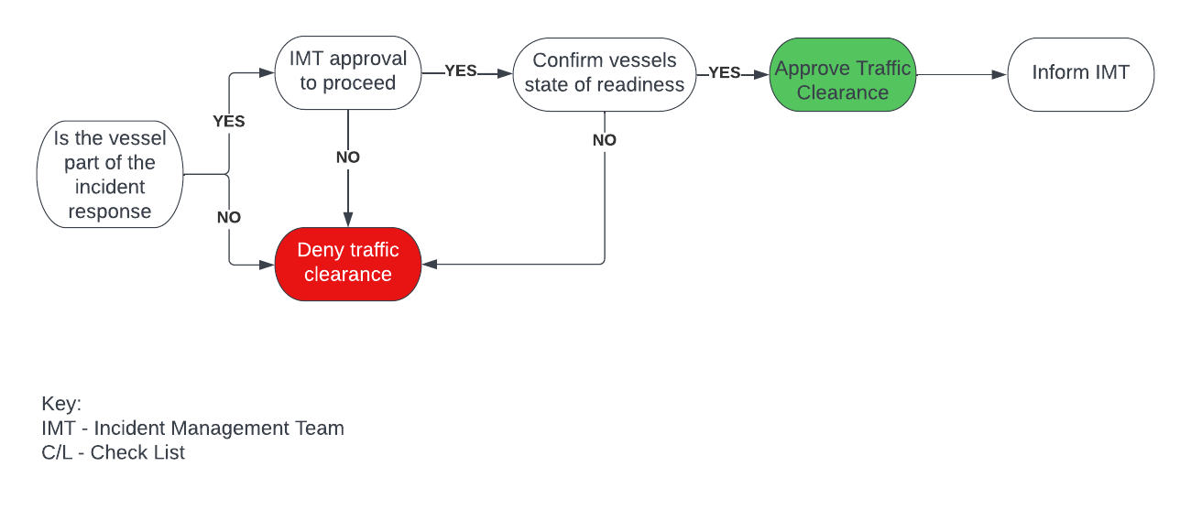The below flow chart shall be used to determine if a vessel has clearance to enter an exclusion zone

Responsibilities: | - Safety of self and team  - Respond as requested by the OSC Ashore  - Communicate with OSC Ashore
Task |  | Notes
Prior to Deployment
Form a Shore response Team
- Minimum of 2 people
- Maximum of 5 people
Assign a Shore response Team Leader
Team Leader to collect Intrinsically safe, portable hand held radio
Team Leader to collect an atmosphere monitor
Team Leader to ensure that all team members have appropriate PPE
Team Leader to establish communications with the On Scene Commander Ashore
Team Leader to Report to On Scene Commander Ashore that the team is standing by and ready for deployment
Team to respond as directed by the On Scene Commander Ashore
Upon Deployment
Continue to assess Safety to yourself and your team
Pass information to On Scene Commander Ashore

All Scenarios

SIC Shore Response Teams Checklist

Executive Manager – Action Card
All Scenarios | Action Card: Executive Manager
Responsibilities: | - Health and safety of all operations within the port  - Support DHM  - Business continuity  - Communicate with DHM & other council / external parties
Task |  | Notes
Start new Incident Log
Obtain information from DHM
If in danger, evacuate immediately
Call Director Infrastructure
Call Emergency Planning and Resilience Officer
Call SIC Communications
Maintain communication with DHM
Establish and maintain communications with Emergency Management Team
Inform SIC Emergency Management Team when SHO / SVHA ICR has been established
Regularly assess the impact of the event with the management team
Provide Situation reports
Consider impact of Port closures (e.g. to outer Isles)
Consult with Engineering / SVT to estimate the length and expense of “clean up” period

Annex I - Identified Resources & Capabilities

Fleet - Tug Vessels

Tystie
FIFI capability | 2 x water spray at 1200m3 /hour + 1 foam monitor
Foam Capacity | 38m3 held on-board - Aquafilm AFFF
MOB capability | 1 x Jason’s rescue stretcher
Pollution capability | 13m3 of dispersant - Slikgone NS. Capable of covering 88 hectares at 5 knots.
Maximum speed | 13 knots
Bollard pull | 55 Tonnes ahead / 50 Tonnes astern

Dunter
FIFI capability | 2 x water spray at 1200m3 /hour + 1 foam monitor
Foam Capacity | 38m3 held on-board - Aquafilm AFFF
MOB capability | 1 x Jason’s rescue stretcher
Pollution capability | 13m3 of dispersant - Slikgone NS. Capable of covering 88 hectares at 5 knots.
Maximum speed | 13 knots
Bollard pull | 55 Tonnes ahead / 50 Tonnes astern

Shalder
FIFI capability | 2 x water spray at 1200m3 / hour + foam monitor
Foam Capacity | None held on-board
MOB capability | 1 x Jason’s stretcher + 1 x Jason’s Cradle
Pollution capability | Skimmer & Boom deployment
Maximum speed | 14 knots
Bollard pull | 83 Tonnes ahead / 70 Tonnes Astern

Tirrick
FIFI capability | 2 x water spray at 1200m3 / hour + foam monitor
Foam Capacity | None held on-board
MOB capability | 1 x Jason’s stretcher + 1 x Jason’s Cradle
Pollution capability | Skimmer & Boom deployment
Maximum speed | 14 knots
Bollard pull | 83 Tonnes ahead / 70 Tonnes Astern

Fleet - Pilot Launches

Sullom Shoormal
FIFI capability | N/A
MOB capability | MOB Lift
Pollution capability | Monitoring / collection samples
Maximum speed | 18 Knots
Bollard pull | N/A

Sullom Spray
FIFI capability | N/A
MOB capability | MOB Lift
Pollution capability | Monitoring / collection samples
Maximum speed | 18 Knots
Bollard pull | N/A

Sullom Spindrift
FIFI capability | N/A
MOB capability | MOB Lift
Pollution capability | Monitoring / collecting samples
Maximum speed | 18 Knots
Bollard pull | N/A

Fleet - Workboats

Shearwater
FIFI capability | N/A
MOB capability | MOB recovery pole (Conscious casualties only)
Pollution capability | Monitoring / boom deployment / collecting samples
Maximum speed | 8 knots
Bollard pull | N/A

Fleet - Mooring Boats

Sullom A, B & C
FIFI capability | N/A
MOB capability | Overboard ladder (Conscious casualties only)
Pollution capability | Monitoring / boom deployment / collecting samples
Maximum speed | 8 knots
Bollard pull | N/A

Fleet – Ports & Harbours Road Vehicles
Vehicle | Equipment
Pollution pick up | Tier 1 Pollution equipment
DHM van x 2 | Tier 1 Pollution equipment

Notice Periods
Fleet - Response Times - Tanker in Port
1st Duty Tug | 15 minutes
2nd Duty Tug | 15 minutes
3rd Duty Tug | 2 Hours
4th Duty Tug | Dependent on crew availability
1st Duty Launch | 15 minutes
2nd Duty Launch (Call back crew) | 4 hours

Fleet - Response Times - No Tanker in Port
1st Duty Tug | 15 minutes
2nd Duty Tug | 1 Hour
3rd Duty Tug | 2 Hours
4th Duty Tug | Dependent on crew availability
1st Duty Launch | 15 minutes
2nd Duty Launch (Call back crew) | 4 hours

Medical Equipment Available
Recourse | Location
First Aid station | 1st Floor Kitchen, Port Admin Building
First Aid Station | Ground Floor Kitchen, Port Admin Building
First aid station | Engineering workshop
Defibrillator | Main entrance, Port Admin Building
Defibrillator | X 4 - 1 on each tug

Portable hand held radios are kept in the following locations
Location | Number of Portable Radios
Harbour Master’s Office | 1 x VHF
Deputy Harbour Master’s Office | 1 x VHF
Port Safety Officers’ Offices | 2 x VHF
Towage Engineering Superintendent Office | 1 x VHF & 1 x UHF
Pilots Office | 3 x VHF
Workshop | 3 x VHF & 5 x UHF

Portable Atmosphere Monitors
Location | Number of monitors
Workshop | 6
Port Safety Officer’s Office | 2

Departmental Staff

Total Staff numbers (approx.)
Department | Number of staff | Line Manager | Contact
Workshop | 16 | Team Lead Port Engineering | 4203
Admin | 10 | Team Lead Engineering & Operations Support | 4208
VTS | 6 | Team Lead Deputy Harbour Master | 4202
Scalloway | 4 | Team Lead Deputy Harbour Master | 4245

First Aiders
Department | Number of First Aiders | First Aiders Post Titles | Contact
Workshop | 2 | Senior Technical Engineers | 4298 / 4263
Ports | 2 | Port Safety Officers | 4278 / 4277
Scalloway | 1 | Small Ports Supervisor | 4221

Annex II - Incident Log
Incident: |  |  |  |  |  | Page No.
Date : |  | Name: |  |  | Location:
Time |  |  |  | Details

Annex III - Situation Report / METHANE Template
Time |  | Date
Organisation
Name of Caller |  | Tel No

M | Major Incident | Has a Major Incident been declared?  YES/NO  (If no, then complete ETHANE message)
E | Exact Location | What is the exact location or geographical area of incident
T | Type of Incident | What kind of incident is it?
H | Hazards | What hazards or potential hazards can be identified?
A | Access | What are the best routes for access and egress?
N | Number of casualties | How many casualties are there and what condition are they in?
E | Emergency Services | Which and how many emergency responder assets/personnel are required or are already on-scene?
Restricted once complete

Signature

