Click here to enter text.‘s Plan

Section 1  Child  ☐ |  | Section 2  Assessment  ☐ | Section 3  Action Plan  ☐ |  | Section 4  Compulsory Measures  ☐  Delete if not required |  | Section 5  CSP  ☐  Delete if not required | Section 6  Chronology  ☐  Delete if not required
Section 1 – Child

Date of first plan: Click here. |  |  |  | Date of this plan: Click here.
Date of last review: Click here. |  |  |  | Date of next review: Click here.
Child/Young person details
Name: Click here to enter text.  Date of birth: Click here to enter DoB  Age: Click here to enter age. |  |  |  |  | UPN: Click here to enter UPN.  CHI: Click here to enter CHI.  SWIFT Number : Click here to enter  (if appropriate)
Gender: Choose an item.  First/Home language: Choose an item. |  |  |  |  | Stage of Intervention (1-3): Click here.  Young Carer statement: Yes/No Click here  
Has the child’s current address or any other information been withheld from this plan?
If yes, detail what and why: Click here to enter text.
Home address: Click here to enter text.  Postcode: Click here to enter. |  |  |  |  |  | Current address (if different from home address): Click here to enter text.  Postcode: Click here to enter text.
Education/Early years establishment:  Click here to enter text.  Date of entry to current establishment: Click here.  Year group: Click here.  Level of school attendance in current academic year: Click here |  |  |  |  |  | Health Visitor / School Nurse (delete as appropriate): Click here to enter text.  GP and Practice: Click here to enter text.  Childrens Social Work: Click here to enter text.
Named Person: Click here |  |  |  |  |  | Lead Professional: Click here to enter text.  CSP Co-ordinator (check details required in Annotated Plan): Click here to enter text.
Are there any statutory measures in place?
Please provide details:
Click here to enter text.

Why does this child need a plan?
Safe  ☐ | Healthy  ☐ | Achieving  ☐ | Nurtured  ☐ | Active  ☐ | Respected & Responsible  ☐ | Included  ☐
Please provide a summary
: Click here to enter text.

(*** If this is a CSP please check guidance in the Annotated Plan***)

People living at the child’s home address
Name | DoB | Relationship to child | Parental rights
Click here to enter text. | Click here. | Click here to enter text. | ☐
Click here to enter text. | Click here. | Click here to enter text. | ☐
Click here to enter text. | Click here. | Click here to enter text. | ☐
Click here to enter text. | Click here. | Click here to enter text. | ☐
Click here to enter text. | Click here. | Click here to enter text. | ☐
Click here to enter text. | Click here. | Click here to enter text. | ☐

Other significant family members/people
Name | Address | Date of Birth | Relationship to child | Parental rights
Click here. | Click here. | Click here. | Click here. | ☐
Click here. | Click here. | Click here. | Click here. | ☒
Click here. | Click here. | Click here. | Click here. | ☐
Click here. | Click here. | Click here. | Click here. | ☐
Click here. | Click here. | Click here. | Click here. | ☐
Click here. | Click here. | Click here. | Click here. | ☐

Is there a sibling or an individual with sibling type relationship to be considered?
☐ Yes, see attached report(s)
☐ No

Has the child/young person/parent/carer been offered Advocacy support? (Please record a summary of the discussion and the decision reached)
Click here to enter text.

Information sharing (Parental, YP consent to share plan, child agreement to share plan)
Click here to enter text.

Preferred language or form of communication and support required to attend meetings (Child and parents)
(e.g. use BSL, needs interpreter, prefers contact by mobile phone, disabled access, supporter, etc.)
Click here to enter text.

Section 2 – Assessment

Who has contributed to the assessment and Action Plan, since the last meeting, and how?
Click here to enter text.
Please note any additional specialist assessments/protocols in place?
(Eg Individualised Education Plan, Moving and Handling Protocol, Neurodevelopmental Assessment, Behaviour Support Plan, Intimate Care Protocol, Medical Protocol, Parenting Assessment etc.)
Click here to enter text.

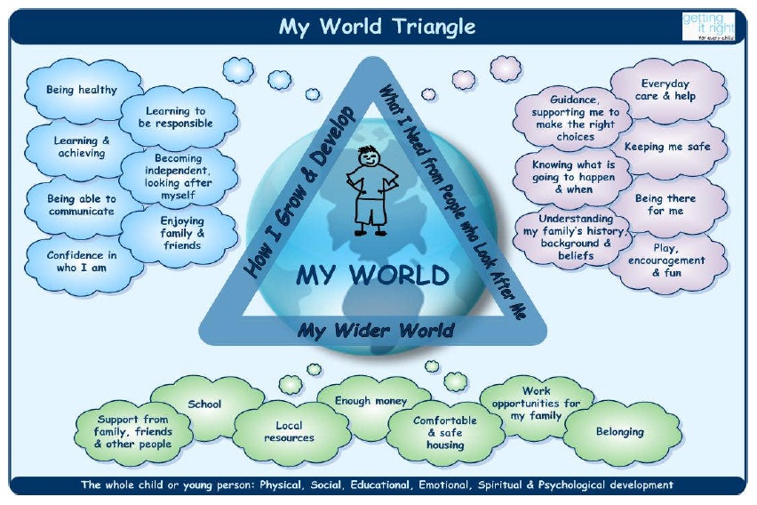

Strengths from My World Triangle

Pressures from My World Triangle
(include current risks and needs analysis)
Click here to enter text.

In analysing the strengths and pressures:
How will the needs be responded to?
Click here to enter text.

How will the risks be responded to?
Click here to enter text.

What are the long term goals for the child?
Click here to enter text.

Section 3 – Action Plan

Review of Previous Action Plan |  | Achie-ved?
Actions/Methods | What went well? What didn’t go well?  What needs to happen? | Y | N
Click here to enter text. | Click here to enter text. | ☒ | ☒

Agreed Actions for THIS Plan
Desired Outcomes/ targets | Actions/Methods | By Whom | By When | SHA-NAR-RI
Click here to enter text. | Click here to enter text. | Click here to enter text. | Click here to enter text.

Partners to THIS plan (include child/young person, parents/carers and professionals)
Name | Role | Telephone | Contribution to Plan (Consultation, Attended Meeting, Sent Report, etc)
Click here. | Click here. | Click here. | Click here.
e-mail:
Click here. | Click here. | Click here. | Click here.
e-mail:
Click here. | Click here. | Click here. | Click here.
e-mail:
Click here. | Click here. | Click here. | Click here.
e-mail:
Click here. | Click here. | Click here. | Click here.
e-mail:
Click here. | Click here. | Click here. | Click here.
e-mail
Click here. | Click here. | Click here. | Click here.
e-mail:
Click here. | Click here. | Click here. | Click here.
e-mail:

Child/Young Person’s views (must be completed)

Parents’/Carers’ views (must be completed)
Sibling / Individual with sibling type relationship’s views (as appropriate)
Click or tap here to enter text.

Note and explain any disagreements with any areas of the Action Plan between any partners to the plan (professional or child/family) and any further actions required
Click here to enter text.

Contingency planning
Click here to enter text.

Section 4 – Compulsory Measures
(Delete this section if not required)

This section to be completed whenever:
- The Reporter has requested a report; or
- Referral is being made to the Reporter; or
- The child is coming to a Children’s Hearing.

Is the recommendation that compulsory measures are required?

WHY is that recommendation made? What is the EVIDENCE that the Action Plan can or cannot be achieved on a voluntary basis?
Click here to enter text.

If compulsory measures ARE recommended, WHAT specific conditions (if any) would support the Action Plan?
Click here to enter text.

WHY are those specific conditions recommended?
Click here to enter text.

Section 5 – Co-ordinated Support Plan (CSP) Learning Plan
(Delete this section if not required)

(if in place)
Educational objectives | Additional support required | Additional support provided by
Click here to enter text. | Click here to enter text. | Click here to enter text.

Nominated school
Name of school: Click here to enter text.
Address: Click here to enter text.
Telephone: Click here to enter text.
Headteacher: Click here to enter text.
Nature of placement: Click here to enter text.

The CSP Learning Plan is not authorised as a statutory part of the Child’s Plan unless this part is completed

Date: Click here to enter a date.  Next CSP review must be held by: Click here to enter a date. | Authorised by: Click here to enter text.

Signatures
(On Completion Of Assessment)

 | Name | Signature / location of signature on electric version | Date
Child / Young Person |  |  | Click here to enter a date.
Parent / Carer |  |  | Click here to enter a date.
Parent / Carer |  |  | Click here to enter a date.
Writer of Plan |  |  | Click here to enter a date.

*Is this also a CSP? If yes, please complete-
All fields marked with an asterisk must be completed to meet legal requirements for a CSP.
 | Name | Signature / location of signature on electric version | Date
Director of Children’s Services |  |  | Click here to enter a date.

Section 6 – Chronology

Date: | Significant Event | Source of Information | Action taken/Outcome | Recorded by

