NOTES
Headings or notes in red indicate essential content.
Notes in green are advisory guidance.
In all cases the Plan should be proportionate and avoid repetition.

Mintie Meenie‘s Plan

You can add how long the plan is running for
i.e. September – December 2021
If sharing paper copies for Child Plan meetings, etc. you need only print those pages that hold information, for example, where a child does not have a CSP or Compulsory Measures in place, delete those sections.
You can edit the footer by adding the child’s name so it reads ‘Mary’s Child Plan’. You can also replace ‘Version 5a July 2018’ with the date of this Plan. This is particularly useful if paper copies are made and pages get detached.
You can also use this space to personalise the plan with a picture by the child, photograph or other suggestions agreed with the child and where appropriate the family/carers.

Section 1  Child  ☐ | Section 2  Assessment  ☐ | Section 3  Action Plan  ☐ | Section 4  Compulsory Measures  ☐  Delete if not required | Section 5  CSP  ☐  Delete if not required | Section 6  Chronology  ☐  Delete if not required
Section 1 – Child
Date of first plan: The date of the first meeting |  |  |  |  | Date of this plan: The date of this meeting
Date of last review: This will usually be the last meeting |  |  |  |  | Date of next review: This will be decided at this meeting
Child/Young person details
Name: Click here to enter text.  Date of birth: Click here to enter DoB  Age: Click here to enter age. |  |  |  |  |  | UPN: the School secretary can get this for you  CHI: Health number  SWIFT Number : Social work number if it they have one  (if appropriate)
Gender: Choose an item.  First/Home language: Choose an item. |  |  |  |  |  | Stage of Intervention (1-3):  Young Carer statement: Yes/No Click here –Record on SWIFT. Record on SEEMiS  
Has the child’s current address or any other information been withheld from this plan?
If yes, detail what and why: Click here to enter text.
Home address: Click here to enter text.  Postcode: Click here to enter. |  |  |  |  |  |  | Current address (if different from home address): Click here to enter text.  Postcode: Click here to enter text.
Education/Early years establishment:  What school or nursery do they attend  Date of entry to current establishment: Click here.  Year group: Click here.  Level of school attendance: As % of attendance from SEEMiS |  |  |  |  |  |  | Health Visitor / School Nurse (delete as appropriate): Click here to enter text.  GP and Practice: Click here to enter text.  Childrens Social Work: Click here to enter text.
Named Person: Often health visitor pre-school, Pupil Support for secondary, see Shetland Practice Framework for detail |  |  |  |  |  |  | Lead Professional: Must be included  CSP Co-ordinator: If there is one, must give name and contact details, along with name and contact details of person who is available for advice and information – currently QIO for ASN.
Are there any statutory measures in place?
Please provide details:

Essential, if they exist
Why does this child need a plan?
Safe  ☐ |  | Healthy  ☐ | Achieving  ☐ | Nurtured  ☐ |  |  |  | Active  ☐ | Respected & Responsible  ☐ | Included  ☐
Please provide a summary:
This must be filled in, along with the relevant boxes above: Give a short, clear account of why this plan is necessary, noting any diagnosis that has been given or identification of additional needs. Include information that would help someone who doesn’t know the child and is reading it for the first time. No need for any chronology in this section though.

CSP Note: The Child’s Plan must state the conclusions as to the factor or factors from which the additional support needs of the child or young person arise.

People living at the child’s home address
Name | DoB | Relationship to child | Parental rights
Click here to enter text. | Click here. | Click here to enter text. | ☐
Click here to enter text. | Click here. | Click here to enter text. | ☐
Click here to enter text. | Click here. | Click here to enter text. | ☐
Click here to enter text. | Click here. | Click here to enter text. | ☐
Click here to enter text. | Click here. | Click here to enter text. | ☐
Click here to enter text. | Click here. | Click here to enter text. | ☐

Other significant family members/people
Name | Address | Date of Birth | Relationship to child | Parental rights
Click here. | Click here. | Click here. | Click here. | ☐
Click here. | Click here. | Click here. | Click here. | ☐
Click here. | Click here. | Click here. | Click here. | ☐
Click here. | Click here. | Click here. | Click here. | ☐
Click here. | Click here. | Click here. | Click here. | ☐

Is there a sibling or an individual with sibling type relationship to be considered?
☐ Yes, see attached report(s)
☐ No

Has the child/young person/parent/carer been offered Advocacy support? (Please record a summary of the discussion and the decision reached)
Record a brief description of the conversation noting the types of advocacy offered and record any reasons why offer declined and/or record which support is accepted and how the introduction will be made.

Information sharing (Parental, YP consent to share plan, child agreement to share plan)
Best practice: the date at which consent has been given to share what, with whom i.e. ‘Mum gave consent to share plan with Community Paediatrician 23/2/18’. Any child over 12 yrs old also MUST give consent too, where they have capacity.

Preferred language or form of communication and support required to attend meetings (Child and parents)
(e.g. use BSL, needs interpreter, prefers contact by mobile phone, disabled access, supporter, etc.)
Essential if there are specifics. Also, if applicable you can note in here preferred times that work around parents’ jobs so you know when to avoid timetabling meetings.
Section 2 – Assessment
Who has contributed to the assessment and Action Plan and how?
Who is at the Child’s Plan meeting and who has contributed new reports or information since the last meeting.
There may have been specialist assessments, or meetings with family members who have contributed information for the assessment.

Please note any additional specialist assessments/protocols in place?
(Eg Individualised Education Plan, Moving and Handling Protocol, Neurodevelopmental Assessment, Behaviour Support Plan, Intimate Care Protocol, Medical Protocol, Parenting Assessment etc.)
The above list is not exhaustive – note any supporting documents that are important for the support of the C/YP. Please put N/A if that is the case.
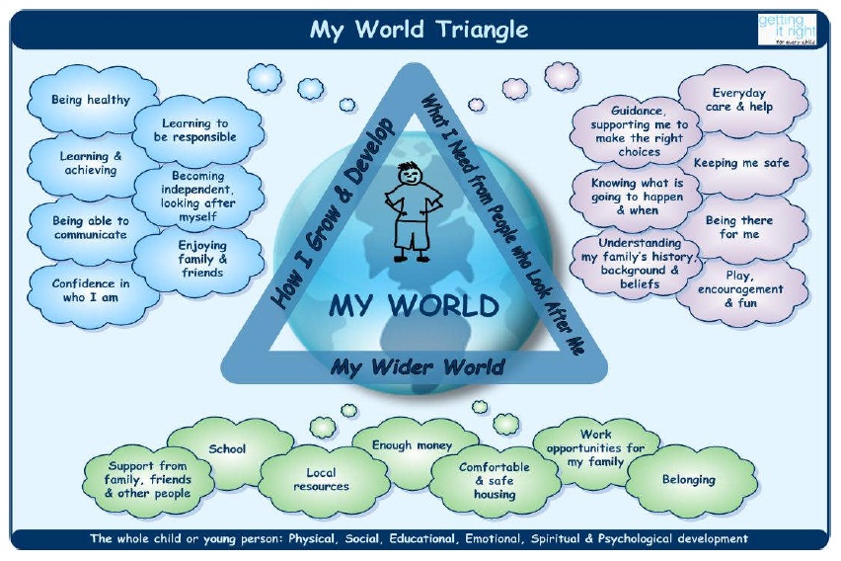

Strengths from My World Triangle
The next 2 sections can be filled in several ways. Use the My World Triangle to ensure all aspects of the Child/Young person’s life are considered. Only give the facts just now – leave the impact for the next part.
Possible stylistic approaches include:
- Use bullet points (preferred for complex Plans)
- Write in prose
- Write in 1st person
- Allocate the comments to partners to the plan to ensure everyone’s voice is represented
Include here strategies that need to be in place to support the C/YP – eg. Visual Timetable, Brain Breaks, Study Periods. These were maybe introduced in previous plans and are known to be effective and should be in place as standard for the C/YP so should be noted.

Pressures from My World Triangle
(include current risks and needs analysis)
As above, also use bullet points summarising the areas the action plan needs to address. Use this space for clear risk assessment.

In analysing the strengths and pressures:
How will the needs be responded to? How will the risks be responded to? What are the long term goals for the child?

It is important to consider the impact on the child of the needs and risks that you have identified in the plan.

In some situations it may be appropriate to add headings for ‘Conclusions’, ‘Recommendations’. This may be relevant for the situation or to meet national requirements, e.g. for Children’s Reporter.

Section 3 – Action Plan

Review of Previous Action Plan |  | Achie-ved?
Actions/Methods | What went well? What didn’t go well?  What needs to happen? | Y | N
Copy and paste from previous plan  State N/A if this is a first plan. | Give an evaluative comment.  State N/A if this is a first plan. | ☐ | ☐

Agreed Actions for THIS Plan
Desired Outcomes/ targets | Actions/Methods | By Whom | By When
These can also be bullet pointed to match the long term goals mentioned at the end of the assessment – this means that every area will have actions.  There should be consideration of whether an IEP should be put in place and if necessary, added to the actions if agreed.  If this is a CSP educational objectives should be added to Section 5 only. | Click here to enter text. | Specify name and role (e.g. SaLT) | You must include timescales that are as specific as well as practicable. E.g. ‘Twice a week until Jan 19)

Partners to THIS plan – only include people who have actions in this plan
Occasionally there may be other key partners such as a Community Paediatrician, a Parent with parental rights who should be Partners to this plan – use your professional judgement
Name | Role | Telephone | Contribution to Plan (Consultation, Attended Meeting, Sent Report, etc)
Click here. | Click here. | Click here. | Click here.
e-mail:
Click here. | Click here. | Click here. | Click here.
e-mail:
Click here. | Click here. | Click here. | Click here.
e-mail:
Click here. | Click here. | Click here. | Click here.
e-mail:
Click here. | Click here. | Click here. | Click here.

Child/Young Person’s views (must be completed)
This must be filled in.
Depending on their ability and understanding, children will need to be approached differently to get this information. Inviting the children/young people along to the meeting is important – it is their meeting and their views are important. Professionals should be mindful of the impact which the content of the meeting may have on the young person. Think about the age and stage of the pupil – maybe joining the meeting for 5 minutes at the beginning/end is more appropriate than the whole meeting.
- Some people ask children to fill in a 2 stars and a wish sheet to take with them to the meeting – preparing something beforehand gives them confidence to take part or if they chose not to attend their views can still be shared with Partners.
- Others get young people to write/draw free form their view.
- Children with cognitive and/or physical difficulties can be involved by including pictures of things they enjoy doing or using their usual assistive technology. Sometimes adults may need to state what they observe for the young person
- Talking mat activity – if done beforehand with the pupil can be photographed and inserted.
- Templates are available on the webpage for helping to capture the Child’s voice.

Parents’/Carers’ views (must be completed)
This must be filled in.
If agreed by the parents it could be a summary of what the parents/carers said at the meeting. If parents have been asked to supply this either by letter or phone conversation and it doesn’t come in - note that in this section.

Note and explain any disagreements with any areas of the Action Plan between any partners to the plan (professional or child/family) and any further actions required
If there are none – please state N/A.

Contingency planning
This section lets all partners to the plan know what to do if x, y, z happens
E.g. ‘If attendance falls below 80%, the Head teacher will contact the parent and relevant partners to call a meeting.’

Section 4 – Compulsory Measure
(Delete this section if not required)

This section to be completed whenever:
- The Reporter has requested a report; or
- Referral is being made to the Reporter; or
- The child is coming to a Children’s Hearing.

Is the recommendation that compulsory measures are required?

WHY is that recommendation made? What is the EVIDENCE that the Action Plan can or cannot be achieved on a voluntary basis?
Section 4 would be completed by a Social Worker, where relevant.

If compulsory measures ARE recommended, WHAT specific conditions (if any) would support the Action Plan?
Click here to enter text.

WHY are those specific conditions recommended?
Click here to enter text.

Section 5 – Co-ordinated Support Plan (CSP) Learning Plan
(Delete this section if not required)

(Only fill in if in place – if in place every box must be filled)
Educational objectives | Additional support required | Additional support provided by
Criteria for a co-ordinated support plan:  • needs arising from more than one or more complex factor or multiple factors which lead to a significant adverse effect on the school education of the c/yp;  • needs likely to continue for more than a year as evidenced by professional judgement indicating probability of needs lasting > year;  • the young person requires significant additional support to be provided by the education authority and at least one more agency or service within the Local Authority.  Young people requiring a co-ordinated support plan will have reached Stage 3 of the Stages of Intervention. Please follow the process at: https://www.shetland.gov.uk/education/Guidelines6CSPsandIEPs.asp  All new CSPs must be agreed at a monthly ASN Management Team multi-agency meeting. This must be discussed initially with QIO for ASN. | All content in these sections will be copied from the ‘signed off’ CSP. | All content in these sections will be copied from the ‘signed off’ CSP.

Nominated school
Name of school: Click here to enter text.
Address: Click here to enter text.
Telephone: Click here to enter text.
Head teacher: Click here to enter text.
Nature of placement: Click here to enter text.

The CSP Learning Plan is not authorised as a statutory part of the Child’s Plan unless this part is completed

Date: Click here to enter a date.  Date by which review must begin: (on the expiry of 12 months from the date the Plan was made/amended:  Date by which review must be completed:  (within 12 weeks of the date on which the review began) | Authorised by: Click here to enter text.

Signatures
(On Completion Of Assessment)

 | Name | Signature / location of signature on electric version | Date
Child / Young Person |  |  | Click here to enter a date.
Parent / Carer |  |  | Click here to enter a date.
Parent / Carer |  |  | Click here to enter a date.
Writer of Plan |  |  | Click here to enter a date.

*Is this also a CSP? If yes, please complete-
All fields marked with an asterisk must be completed to meet legal requirements for a CSP.
 | Name | Signature / location of signature on electric version | Date
Director of Children’s Services |  |  | Click here to enter a date.

Section 6 – Chronology

Chronology of significant events
It is not appropriate for detailed chronology from information systems to copied and pasted in full, e.g. SEEMiS.

This section can be removed for sharing with the child/young person/family if it is felt that the content would be inappropriate or have a negative impact.

The chronology should be written with a family and the content shared – I think the issue is that a full chronology may not need to be tabled at every meeting. Wendy 4/11

For further information see the Care Inspectorate Guide: https://www.careinspectorate.com/images/documents/3670/Practice%20guide%20to%20chronologies%202017.pdf

