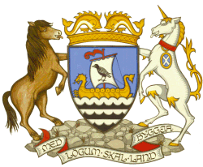
Shetland Islands Council

Civic Government (Scotland) Act 1982 (Licensing of Short-Term Lets) Order 2022

SHORT-TERM LET LICENSING
OBJECTION FORM

This from should be received by the Council within 28 days from when the notice of application was displayed and submitted to:

Email: stl@shetland.gov.uk
Address: Shetland Islands Council, Environmental Health, Gutters’ Hut, 7 North Ness, Lerwick, Shetland,
ZE1 0LZ
Name of person making an Objection/Representation
Address of Person making an Objection/Representation

Address or Licence Number of Short Term Let Property

Please specify the Grounds for Objection:
Please specify the Nature of the Representation:

Signature |  | Date
Name (BLOCK CAPITALS)

