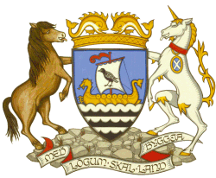
Shetland Islands Council
Civic Government (Scotland) Act 1982
(Licensing of Short-term Lets) Order 2022

SHORT-TERM LETS LICENCE
CONFIRMATION OF DISPLAY OF PUBLIC NOTICE

This section must be completed by the applicant and the whole notice returned to the Licensing Authority at the below address at the end of the 21-day display period. Alternatively please provide confirmation of display in writing with signature, along with full applicant and property details.
I, (insert name)
being the applicant for a Licence in terms of The Civic Government (Scotland) Act 1982 (Licensing of Short-term Lets) Order 2022, hereby certify the Notice of application has been displayed as prescribed above for a period of not less than 21 days:
From: |  | To:
Address of Short Term Let:
Containing such information as is required by paragraph 2(3) of Schedule 1 to the above Act.
DELETE WHERE APPROPRIATE

- I confirm that said Notice was NOT removed, obscured or defaced during the above-mentioned period

- I confirm that where the said Notice was removed, obscured or defaced during the above-mentioned period, I took reasonable steps for its protection and replacement as detailed below:

Signature: |  |  | Date:
Name (BLOCK CAPITALS) |  | Position:

Please complete this form after the Site Notice has been displayed for the 21 day period and return the form to: Shetland Islands Council, Environmental Health, The Gutters’ Hut, 7 North Ness, Lerwick, Shetland, ZE1 0LZ

