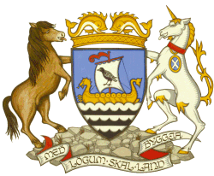
Shetland Islands Council

Civic Government (Scotland) Act 1982 (Licensing of Short-Term Lets) Order 2022

PREMISES OWNERS’ DECLARATION

Type of Licence Application: | ☐ New |  | ☐ Renewal |  | ☐ Variation |  |  | ☐ Temporary
Change in circumstances/other
Type of Letting(s) being carried out:
☐ Secondary Letting (means the letting of property where you do not normally live, e.g. self catering unit)
☐ Home Letting (means using all or part of your own home for short-term lets whilst you are absent, e.g. whilst you are on holiday)
☐ Home Sharing (means using all or part of your own home for short-term lets whilst you are there e.g. B&B)
☐ Home Letting & Home Sharing
Full address of premises in respect of which the licence is applied including Postcode:
Max. No of occupants in premises (inc. guests): |  |  |  | Max. No of Guests: |  |  | Max. No of let bedrooms:
Applicant’s Name
Applicant’s Address

I/We being owners of the above named premises give consent for the above named person to make application for a short-term let licence
Full name | Address | Place of Birth | Date of Birth | Signature | Date

